 | Ministry of Higher Education and Scientific Research  Directorate General of Technological Studies  Higher Institute of Technological Studies of Tozeur

Department of Information Technology

End of Studies Project

In Order to obtain

Applied Bachelor’s Degree in Information Technology

Specialization: Information Systems Development
Exam Flow AI

Prepared by : Tabai Iyadh
Supervised by : Mr . Ben Mahmoud Soufiene
Hosting Organization : ISET Tozeur
Internship Period : Du 02/02/2026 Au 25/05/2026

Signatures

Encadrant ISET

Responsable Entreprise

Résumé
Pour être efficace, votre résumé devrait présenter les caractéristiques suivantes :
- Concision : Il doit être relativement court (généralement entre 200 et 500 mots, ou une page maximum).
- Clarté : Utiliser un langage clair, précis et accessible, en évitant le jargon technique excessif.
- Autonomie : Il doit pouvoir être lu et compris indépendamment du reste du mémoire.
- Exhaustivité : Malgré sa brièveté, il doit couvrir tous les aspects essentiels du projet.
- Précision : Privilégier les informations factuelles et éviter les généralités.
- Structure : Suivre une progression logique du contexte jusqu'aux résultats.

Mots Clés : Microservices, Cloud computing, DevSecOps

Abstract
Une Version Anglaise de résumé

Keywords :

Acknowledgments

First and foremost, I would like to express my deepest gratitude to Higher Institute of Technological Studies of Tozeur for providing me with the opportunity to pursue my studies in an excellent academic environment. I would also like to sincerely thank all my teachers and supervisors for their continuous support, guidance, encouragement, and valuable knowledge throughout my academic journey. Their dedication and advice have greatly contributed to the development of my skills and knowledge.
I would like to extend my sincere appreciation to ISET TOZEUR for welcoming me as an intern and offering me the opportunity to gain practical experience in a professional environment. I am especially grateful to the managers, supervisors, and all staff members for their kindness, patience, and assistance during the internship period. Their guidance, collaboration, and trust helped me successfully complete my tasks and better understand the realities of the professional world.
I would also like to thank my internship supervisor for their valuable recommendations, constructive feedback, and constant availability whenever I needed support. Their experience and advice played an important role in the successful completion of this internship.
Finally, I would like to express my heartfelt thanks to my family, friends, and everyone who supported and encouraged me throughout this experience. Their motivation and confidence in me were a great source of strength and inspiration. I am truly grateful to all those who contributed, directly or indirectly, to the success of my internship and this report.

Dedication

I dedicate this modest work:

To my dear parents,
No dedication could express my profound love, immense gratitude, and greatest respect, as I will never forget the tenderness and devoted love with which they have surrounded me since childhood.

To my family,
For the encouragement and kindness, they have given me, I express my deep gratitude and great respect. Their caring presence has been an invaluable source of strength and inspiration throughout my journey.

To my supervisor,
For exceptional supervision, enlightened advice, and constant support throughout this project.

To all my professors,
Who taught me throughout my studies and ensured my training under the best conditions.

To all my friends,
Who have always encouraged me, to whom I wish even more success, as well as to all those who supported me near or far.

Table of Contents

List of Figures

List of Tables

List of Abbreviations

Glossary

General Introduction

In a constantly evolving digital environment, the ability to effectively meet the specific needs of users has become a major challenge for educational institutions. In this context, intelligent platforms are taking an increasingly important place, particularly in the field of online assessment, exam management, and AI-assisted educational content creation.
It is within this framework that we developed a complete web platform dedicated to academic exam management entitled EXAMFLOW AI, aimed at promoting efficiency, fairness, and scalability of the assessment process between teachers, students, and administrators. This project responds to a growing need for digitalization and optimization of processes related to the management of academic examinations, while leveraging recent advances in Artificial Intelligence to assist teachers in question authoring and student performance review.
Our platform proposes an innovative, intuitive, and secure solution that allows:
- Teachers to create classes, upload course materials, generate questions automatically from PDFs and DOCX files using AI (RAG + LLM), build a question bank, and design exams with chapter weighting.
- Students to register in classes, take exams under controlled time conditions, review their answers, and track their progress over time.
- Administrators to oversee users, manage roles (Student, Teacher, Admin), and monitor the platform's overall activity.
The platform also integrates an AI-powered question generation engine based on a microservices architecture (FastAPI + Qdrant vector database + Google Gemini LLM and Gemini embeddings), which transforms raw educational documents into structured, exam-ready questions, opening the way to concrete opportunities for productivity gain in academic environments. A companion React Native / Expo mobile application (ExamFlowMobile/) is also part of the platform, allowing students to follow exams and their progress on mobile devices.

Chapitre | General Framework of the Project
1

Chapitre

General Framework of the Project

Introduction
In this chapter, we present an overall view of our project. We will first introduce the host organization, followed by an in depth description of the project, including its context, the analysis of existing solutions, the criticisms we draw from them, and our proposed solution. Then, we describe the methodology and modeling language adopted for the project .

Presentation of the Host Organization

The Company ISET Tozeur

ISET Tozeur is a Tunisian higher education institute specialized in technological studies, particularly in information systems development, applied computer science, and digital transformation. the institute serves students and the local educational ecosystem in the Tozeur region and is recognized for the quality and practical orientation of its training programs.

With a team of 45 collaborators with advanced expertise and a passionate commitment to innovation, the institute is dedicated to providing high-quality education that meets the specific requirements of the Tunisian job market.


Figure 1: ISET Tozeur Logo

Organizational Chart

The organizational chart of ISET TOZEUR is presented in the figure below :

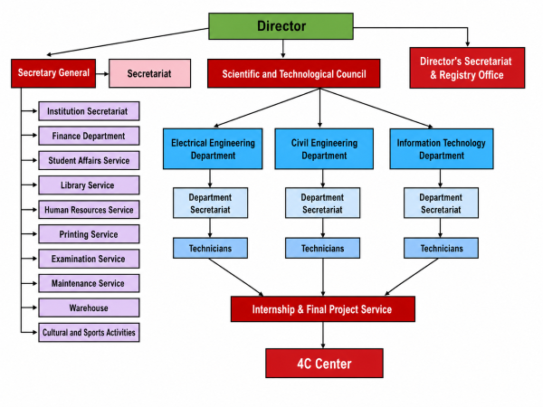
Figure 2 : Organizational Chart of ISET Tozeur

Activities of the Institute

ISET Tozeur offers a complete range of educational and research services:
- Academic training in Information Systems Development, Networks, and Business Management (Licence Appliqué).
- Internship supervision and final-year projects for applied bachelor's degrees.
- Research & Development in digital technologies and educational innovation.
- Professional partnerships with regional companies for student placements.
- Continuing education and technology transfer workshops.

Project Presentation

Project Framework
This project is part of the final-year work required for obtaining the Applied Bachelor's Degree in Information Systems Development at the Higher Institute of Technological Studies of Tozeur. Its purpose is to create a complete and ergonomic web platform entitled EXAMFLOW AI, designed to simplify the organization, generation, and management of online academic exams in higher-education institutions.

Study of Existing Solutions
In this section, we describe the main platforms currently used to manage online exams and educational assessment, in order to identify their limitations and propose improvements for our future platform.

Moodle (Quiz Module)

Moodle is the de-facto open-source LMS used by many universities. Its quiz module allows teachers to create exams with multiple question types. However, the question authoring is fully manual, the UI is dated, and there is no AI-assisted question generation from course materials. Customization requires deep PHP knowledge.

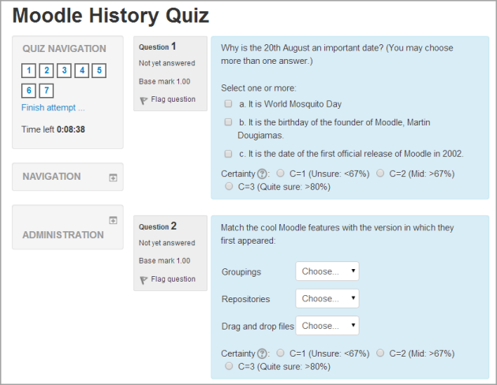
Figure 3: Moodle Quiz interface

Google Forms / Microsoft Forms

These tools are widely used for quick assessments. They are easy to use but lack academic features (chapter weighting, question banks, secure timer enforcement, plagiarism mitigation, advanced analytics) and provide no AI-driven content generation.

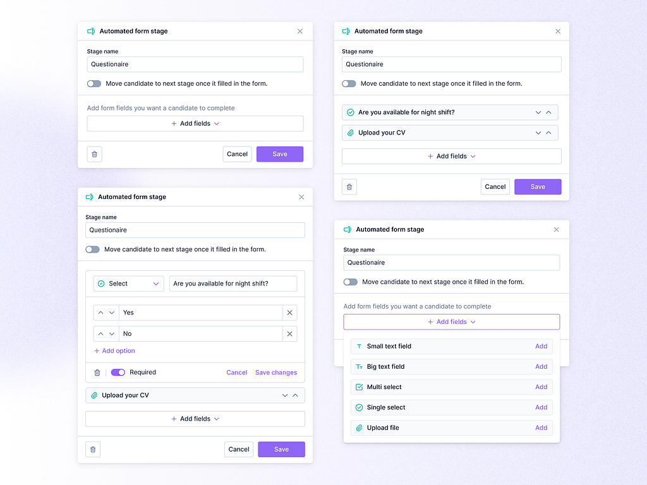
Figure 4: Google Forms interface

ProProfs Quiz Maker / ClassMarker

These commercial platforms offer professional features but are expensive, hosted abroad (data sovereignty concerns), and not adapted to local pedagogical needs (chapter weights, French/Arabic language support, integration with university workflows).

Problems Identified
Several major challenges arise in existing online exam platforms:
- No AI assistance: teachers manually write every question, which is time-consuming.
- Weak time-window security: many platforms rely on client-side timers that can be bypassed.
- Limited integration of course materials: no way to inject a PDF/DOCX and obtain a calibrated question bank.
- Cost and data sovereignty: SaaS solutions are expensive and host data outside the institution.
- Lack of progress tracking per student and per chapter.

Proposed Solution
To address these problems, we propose EXAMFLOW AI, a flexible, secure, and AI-augmented platform, with the following key features:
- AI question generation from PDFs / DOCX files using a RAG pipeline (Qdrant vector DB + Google Gemini LLM with Gemini embeddings).
- Server-authoritative exam grading with manual override (PUT /exam-attempts/:id/grade) for short answers when AI confidence is low.
- Question bank with per-chapter weight distribution (chapterWeights), difficulty levels (easy / medium / hard), three question types (single_answer / multiple_answer / short_answer), and reuse across exams.
- Anti-cheat exam settings: tab-switch detection with maxTabViolations, preventTabSwitching, randomized questions and options, one-question-at-a-time mode, negative marking, partial credit on multiple-answer, and revealMode (limited / full).
- Student progress tracking through visited course modules (Progress.visitedModules).
- Role-based access with five roles (user, admin, teacher, student, institution) and Google OAuth (POST /auth/google/:token).
- OTP / token-based password reset via Nodemailer.
- AI-assisted short-answer review to support teachers during grading.
- Mobile companion application built with React Native / Expo (ExamFlowMobile/).
- Self-hostable via Docker Compose for full data sovereignty.

Adopted Methodology
The Agile methodology is a project management process that prioritizes collaborative work, predictability-based responsiveness, and rapid delivery of value to the client, in contrast to traditional methods that execute projects sequentially with a single plan for the entire project.

Agile Methodology
The Agile approach proposes to considerably reduce or even completely eliminate the tunnel effect by giving more visibility, involving the client from the beginning to the end of the project, and adopting an iterative and incremental process. It considers that needs cannot be fixed and proposes to adapt to changes but with a minimum of rules.

Table 1: Comparison between Agile methods
Agile Method | Description | Advantages | Disadvantages
XP (Extreme Programming) | Agile method emphasizing rapid delivery of high-quality software. | - Focus on code quality (TDD, pair programming).  - Reinforced communication. | - Hard to enforce.  - Requires highly skilled team.
Kanban | Agile method focused on visualizing and optimizing the workflow. | -Clear process visualization.  -Flexibility for continuous flow. | - Less suitable for fixed-scope deliveries.  - Hard for distributed teams.
Scrum Framework | Agile framework focused on collaboration and iteration via sprints. | -Encourages communication.  -Flexible.  - Rapid delivery via sprints. | - Requires experienced team.  - Requires rigorous project management.
We selected the Scrum method, which provides increased visibility on the project and allows faster integration of changes.

SCRUM Workspace
Scrum is a framework for the development of complex products, focused on collective efforts to deliver high-value, productive, and creative products often referred to as the agile manifesto.

The Pillars of SCRUM
- Transparency: Facts are presented as they are to all stakeholders.
- Inspection: Daily inspection allows quick detection of deviations between iteration goals, planned work, and daily reality.
- Adaptation: After noting shortcomings and what can be improved, we seek continuous improvement by adapting based on inspection results.

The Roles of SCRUM
- Product Owner: Aligns the Scrum team on product objectives, taking commercial needs and customer expectations into account.
- Scrum Master: Ensures team effectiveness by applying Scrum values, leading meetings, and removing obstacles.
- Development Team: Concretely realizes sprint tasks; includes the various professionals needed to meet objectives.

The Events of SCRUM
- Sprint Planning: Defines what will be delivered and how.
- Daily Scrum (Stand-up): 15-minute daily meeting to track progress and detect obstacles.
- Sprint Review: Allows the team to present completed work and gather stakeholder feedback.
- Sprint Retrospective: Evaluates the sprint to improve team dynamics, processes, and tools.

Unified Modeling Language (UML)
UML is a standardized graphical language for modeling software development and object-oriented design. With 14 types of diagrams, we chose four to explain the operation of our platform:
- Class Diagram: Models the static structure of the system.
- Use Case Diagram: Globally shows the actions an actor can perform in the system.
- Sequence Diagram: Illustrates the chronology of message exchanges between objects.
- Activity Diagram: Represents the flow and steps of a process or activity.

Project Management with SCRUM
Table 2: Scrum Roles
Scrum Roles | Responsible
Product Owner | Mr. BEN MAHMOUD Soufiene
Scrum Master | Mr. SALAH Daoud
Dev Team | Iyadh TABAI

System Actors
The User model defines five roles: user, admin, teacher, student, institution.
- Admin: Manages all users (changes role, changes status active / inactive / suspended), views global platform statistics, browses all exams, and consults the audit log.
- Institution: A higher-level account meant to represent an educational institution (university, school) onboards teachers and oversees institutional usage. (Reserved role, prepared for future expansion.)
- Teacher: Creates and manages classes (with subtitle, color), defines courses, uploads course materials (PDF/DOCX), triggers AI question generation, manages a question bank, designs and publishes exams (with chapter-weight distribution and anti-cheat settings), reviews submissions, and performs manual grading overrides.
- Student: Sends class-join requests, accepts invitations, takes exams within scheduled time windows, has tab-switch violations enforced server-side, reviews own answers and feedback, tracks personal progress through visited course modules.
- User: A newly registered account that has not yet been promoted to a teacher / student role.
- AI Service (system actor): Processes uploaded documents (extract text → chunk → embed via Gemini embeddings → index in Qdrant), generates structured questions and short-answer reviews via Google Gemini LLM (gemini-3.1-flash-lite-preview).
- Mobile Client (system actor): React Native / Expo app (ExamFlowMobile/) that consumes the same Express API as the web client.

Product Backlog
The product backlog, a central artifact of Scrum methodology, gathers all expected features expressed as user stories. Each user story is prioritized by the Product Owner to guide release planning and define the content of each sprint.

Table 3: Product Backlog
PBI | Functionality | Priority | Sprint
Visitor
1 | As a visitor, I want to browse the platform's landing page, in order to discover the platform and decide whether to sign up. | High | 1
2 | As a visitor, I want to register an account (Student / Teacher), in order to access the platform's features. | High | 1
Authenticated user (Student / Teacher)
3 | As a user, I want to log in via email/password or Google OAuth, in order to securely access my account. | High | 1
4 | As a user, I want to manage my profile (view / edit / delete), in order to keep my personal information up to date. | Medium | 1
5 | As a user, I want to reset my password by email, in order to recover access when I forget my credentials. | Medium | 1
Student
6 | As a student, I want to join a class via code/invitation, in order to participate in my teacher's course. | High | 2
7 | As a student, I want to view my exam calendar, in order to plan and prepare for upcoming exams. | High | 4
8 | As a student, I want to take an exam with a server-authoritative timer, in order to complete it fairly within the allotted time. | High | 4
9 | As a student, I want to review my answers and AI-assisted feedback, in order to understand my mistakes and improve. | High | 4
10 | As a student, I want to track my progress per chapter, in order to identify areas that need more work. | Medium | 4
Teacher
11 | As a teacher, I want to authenticate and manage my profile, in order to securely access my teaching account. | High | 1
12 | As a teacher, I want to create and manage classes, in order to organize my students and course content. | High | 2
13 | As a teacher, I want to upload course materials (PDF / DOCX), in order to share resources with my students and feed the AI service. | High | 2
14 | As a teacher, I want to convert files to markdown via the AI service, in order to prepare content for question generation. | High | 3
15 | As a teacher, I want the AI service to generate questions from materials (RAG + LLM), in order to save time when building exams. | High | 3
16 | As a teacher, I want to manage a question bank (CRUD, filters, validation), in order to curate and reuse quality questions across exams. | High | 3
17 | As a teacher, I want to create exams with chapter weighting, in order to balance coverage according to course priorities. | High | 4
18 | As a teacher, I want to publish, schedule, and close exams, in order to control when students can take them. | High | 4
19 | As a teacher, I want AI-assisted review of short answers, in order to speed up grading while keeping final control. | Medium | 3
20 | As a teacher, I want to grade and publish results, in order to share final marks with students. | High | 4
Admin
21 | As an admin, I want to authenticate and manage my profile, in order to securely access administrative functions. | High | 1
22 | As an admin, I want to manage users (list, change role, change status: active / inactive / suspended) and browse all exams, in order to keep the platform safe and well-governed. | High | 1
23 | As an admin, I want to view platform statistics and audit log, in order to monitor usage and investigate incidents. | Medium | 1
Institution (reserved)
24 | As an institution, I want a dedicated account role to oversee teachers and classes within my institution, in order to govern usage at the organization level. | Low | future
Mobile
25 | As a student / teacher, I want to use the platform from a React Native / Expo mobile app, in order to access the platform on the go. | Medium | parallel

Conclusion
In this chapter, we presented the project, the host organization, the existing solutions and their limits, and our proposed solution EXAMFLOW AI. We also presented the chosen methodology (Scrum) and the modeling language (UML). The next chapter is dedicated to the detailed specification of requirements and the description of Sprint 0.

Chapitre | Sprint 0
2

Chapitre

Sprint 0

Introduction
In this chapter, we begin by defining the specification of EXAMFLOW AI by detailing the product backlog. We then present the planning of the different sprints, before describing the hardware and software environment needed to carry out the project.

Specification of Requirements
This section is devoted to the specification of the functional and non-functional requirements of the solution.

Functional Requirements
Table 4: Main Functionalities
PBI | Main Functionality | US Code | User Story
Visitor
1 | Browse the platform | US1.1 | As a visitor, I want to visit the landing page, in order to discover the platform.
2 | Create an account | US2.1 | As a visitor, I want to register as a Student or Teacher, in order to access the platform's features.
Student
3 | Authenticate | US3.1 | As a user, I want to log in with email or Google OAuth, in order to securely access my account.
4 | Manage profile | US4.1–4.3 | As a user, I want to view, edit, or delete my profile, in order to keep my personal information up to date.
5 | Reset password | US5.1 | As a user, I want to recover my password by email, in order to regain access when I forget my credentials.
6 | Join a class | US6.1 | As a student, I want to enter a class code or accept an invitation, in order to join my teacher's class.
7 | View exam calendar | US7.1 | As a student, I want to see upcoming and past exams, in order to plan and prepare for them.
8 | Take an exam | US8.1 | As a student, I want to sit an exam with a server-authoritative timer, in order to complete it fairly within the allotted time.
9 | Review answers | US9.1 | As a student, I want to read AI-assisted feedback on my answers, in order to understand my mistakes and improve.
10 | Track progress | US10.1 | As a student, I want to view my progress per chapter, in order to identify areas that need more work.
Teacher
11 | Authenticate / manage profile | US11.x | —
12 | Create / manage classes | US12.1–12.3 | As a teacher, I want to CRUD classes, in order to organize my students and course content.
13 | Upload course materials | US13.1 | As a teacher, I want to upload PDF or DOCX course materials, in order to share resources with my students and feed the AI service.
14 | Convert files via AI | US14.1 | As a teacher, I want to convert documents to markdown via the AI service, in order to prepare content for question generation.
15 | Generate questions via AI | US15.1 | As a teacher, I want the AI service to generate questions from materials via RAG and LLM, in order to save time when building exams.
16 | Manage question bank | US16.1–16.3 | As a teacher, I want to manage a question bank with CRUD, filters, and validation, in order to curate and reuse quality questions across exams.
17 | Create exams | US17.1 | As a teacher, I want to define chapters, weights, and duration when creating an exam, in order to balance coverage according to course priorities.
18 | Publish / schedule exams | US18.1 | As a teacher, I want to set a time window to publish and schedule exams, in order to control when students can take them.
19 | Review submissions | US19.1 | As a teacher, I want AI-assisted review of short answers, in order to speed up grading while keeping final control.
20 | Grade and publish results | US20.1 | As a teacher, I want to manually override grades and publish results, in order to share final marks with students.
Admin
21 | Authenticate | US21.1 | —
22 | Manage users | US22.1–22.4 | As an admin, I want to list, edit, ban, and unban users, in order to keep the platform safe and well-governed.
23 | View statistics | US23.1 | As an admin, I want to view platform KPIs and statistics, in order to monitor usage and platform health.

Non-Functional Requirements
Non-functional requirements indirectly affect the platform's results and performance, so they must not be neglected. The following criteria must be satisfied:
- Performance: Optimize system performance to ensure fast response times and minimize loading times (lazy loading, caching, indexed Mongo queries).
- Ergonomics: Design a user-friendly interface, easy to use with intuitive navigation and clear arrangement of functionalities (Ant Design + Tailwind).
- Security: All confidential information provided by users will be encrypted (bcrypt for passwords, JWT in HttpOnly cookies, anti-cheat tab-switch detection with maxTabViolations enforcement .
- Availability: The application must be available and reliable (Docker Compose, health checks).
- Extensibility: Easily adapt to new requirements (microservices architecture, swappable LLM providers).

Sprint Planning
The objective of sprint planning is to define short-term goals, generally over a period of two to four weeks, by determining the features to be developed and estimating the work required.

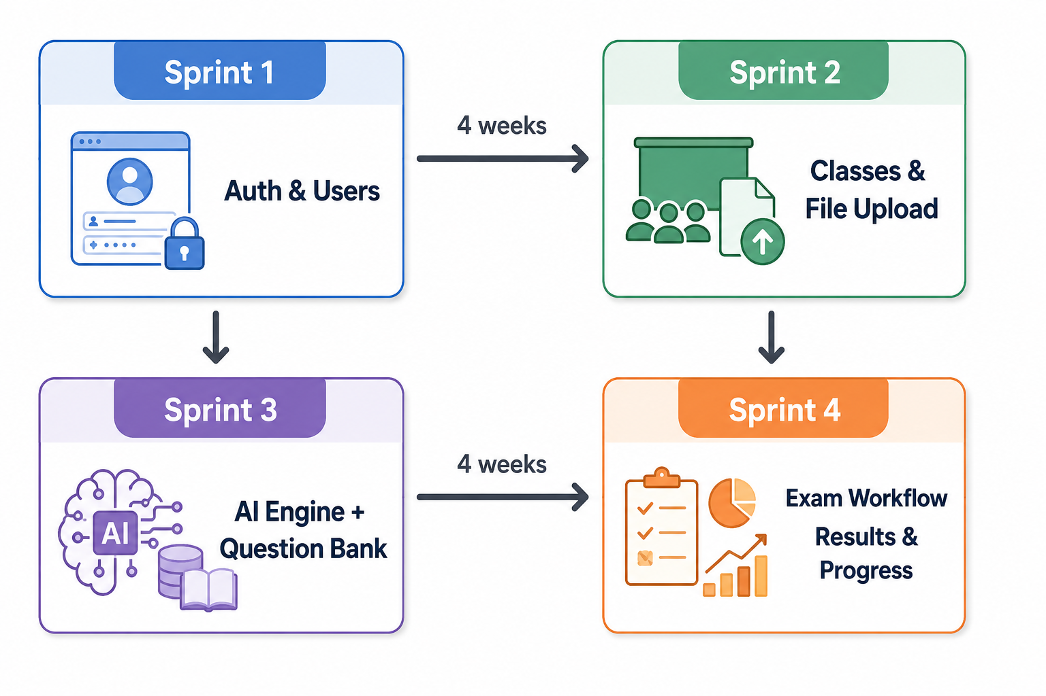
Figure 5 : Sprint Planning

The project was organized into four 4-week sprints, each focusing on the implementation of a specific set of Product Backlog Items (PBIs) to ensure progressive and structured development.

Table 5: Sprint PBI splitting
Sprint | Duration | Main PBIs
Sprint 1 | 4 weeks | PBI 1, 2, 3, 4, 5, 21, 22, 23
Sprint 2 | 4 weeks | PBI 6, 11, 12, 13
Sprint 3 | 4 weeks | PBI 14, 15, 16, 19
Sprint 4 | 4 weeks | PBI 7, 8, 9, 10, 17, 18, 20

Working Environment

Software Environment
- Visual Studio Code: Open-source extensible code editor developed by Microsoft.
- Paradigm , Mermaid: UML modeling tools.
- Docker & Docker Compose: Container orchestration for local development.
- MongoDB Compass: GUI for the MongoDB database.
- Swagger / Postman : API testing.
- Git & GitHub: Source-control and code hosting.

Figure 6: Used Tools and Software

Technologies and Languages Used

Frontend (Client)
The frontend uses modern React technologies for UI development, routing, styling, state management, and API integration.
Table 6 : Front Tools
Technology | Purpose
React 19 | UI framework
Vite | Build tool & dev server
React Router DOM | Client-side routing
Zustand | State management
Ant Design | UI component library
Tailwind CSS | Utility-first styling
Axios | HTTP client
React Markdown | Markdown rendering

Backend (Server)
The backend uses modern Node.js technologies for API development, authentication, database management, file handling, and email services.
Table 7: Backend tools
Technology | Purpose
Node.js + Express 5 | Web framework
MongoDB + Mongoose | Database & ODM
JWT | Authentication tokens
Bcryptjs | Password hashing
Multer | File upload handling
Nodemailer | Email sending (password reset, notifications)

AI Service
The AI service uses modern Python and RAG technologies for document processing, vector search, AI generation, embeddings, and cloud storage.
Table 8 : AI Service Tools
Technology | Purpose
FastAPI | Async Python web framework
Qdrant | Vector database for RAG (similarity search)
Google Gemini API | LLM (gemini-3.1-flash-lite-preview) for generation, conversion, and short-answer review
Gemini Embeddings (gemini-embedding-2) | 768-dimensional embeddings for chunking (1000 chars / 150 char overlap)
LangChain RecursiveCharacterTextSplitter | Text chunking
PyPDF / python-docx | Document parsing
Cloudinary | Cloud file storage

Mobile (ExamFlowMobile)
The mobile application uses React Native and Expo for cross-platform development and seamless integration with the shared backend API.
Table 9: Used Tools for Mobile Application
Technology | Purpose
React Native | Cross-platform UI
Expo | Development & build toolchain
Shared EXPO_PUBLIC_API_URL | Connects to the same Express API as the web client

Infrastructure
The system uses Docker-based containerization and MongoDB to manage the web, API, AI, and mobile services efficiently.
Table 10 : Data Base & Containerization
Technology | Purpose
Docker / Docker Compose | Container orchestration (5 services: mongodb, server, ai-service, client, mobile)
MongoDB 7 | NoSQL database

Hardware Environment
The development and testing environment used desktop systems with Ryzen processors, 16 GB RAM, SSD storage, and dedicated/integrated graphics hardware.

Table 11: Specs of development environment
PC | Lenovo / Desktop
Processor | Ryzen 7 5700U / Ryzen 5 3600
RAM | 16 GB / 16 GB
GPU / AGPU | Vega 8 / GTX 1660 TI
VRAM | 2GB / 6GB
Disk | 512 GB SSD / 256 GB SSD

Conclusion
In this chapter, we presented an overview while focusing on a detailed description of the product backlog and sprint planning. We also identified the working environment, both hardware and software, to provide a comprehensive overview of the elements supporting our project. The next chapter is devoted to the realization of the first sprint, where we will implement the first essential features of the project.

Chapitre | Sprint 1 : Authentication, Profile, and Admin Foundations
3

Chapitre

Sprint 1 : Authentication, Profile, and Admin Foundations

Introduction
In this chapter, we explore the key steps for the realization of the first increment of EXAMFLOW AI. Building on the foundational work of identifying user needs and reviewing global use cases, we now turn our attention to translating those insights into a concrete, functioning product. The goal of this first sprint is not to build a complete system, but to establish a solid, secure, and scalable foundation. Accordingly, the sprint focuses exclusively on the essential features required to launch the platform: authentication, user management, and the admin foundation. These core components will ensure that early users can securely access the system, that their roles and permissions are properly handled, and that administrators have the necessary controls to oversee and manage the environment from day one. By prioritizing these elements, we lay the groundwork for all future development and iterative improvements.

Sprint Objectives
The main objective of this sprint is to deliver the foundational features required by all upcoming sprints:
- Develop an intuitive landing page for visitors.
- Implement a secure account-creation system for Students and Teachers.
- Implement authentication with JWT in HttpOnly cookies + Google OAuth.
- Allow each user to manage their profile (view, edit, delete).
- Implement password reset by email using an OTP code + a reset token with expiry (OTPCode, OTPCodeExpiry, resetToken, resetTokenExpiry fields on the User model), via Nodemailer.
- Provide the Admin with the ability to list users, change their role (user / admin / teacher / student / institution) and status (active / inactive / suspended), browse all exams, view system stats, and consult the audit log.

Sprint 1 Backlog
Table 12 : Sprint 1 Backlog
PBI | Functionality | US Code | User Story | Task ID | Tasks
Visitor
2 | Create account | US2.1 | As a Visitor, I want to register as a Student or Teacher so that I can access the platform with the appropriate role. | 2.1 | Build the registration form (Ant Design).
 |  |  |  | 2.2 | Add client-side validation for required fields.
 |  |  |  | 2.3 | Implement the User Mongoose model (username, email, password, role: ['user','admin','teacher','student','institution'], status: ['active','inactive','suspended'], pfpUrl, numTel, address, googleId).
 |  |  |  | 2.4 | Develop the POST /api/auth/register endpoint.
 |  |  |  | 2.5 | Hash password with bcryptjs.
 |  |  |  | 2.6 | Issue JWT and set HttpOnly cookie.
All authenticated users
3 | Authenticate | US3.1 | As an authenticated user, I want to log in with email/password or Google OAuth so that I can securely access my account using my preferred method. | 3.1 | Build the login form.
 |  |  |  | 3.2 | Develop POST /api/auth/login and GET /api/auth/checkAuth.
 |  |  |  | 3.3 | Integrate @react-oauth/google and verify ID token server-side via POST /api/auth/google/:token.
 |  |  |  | 3.4 | Redirect user to role-specific dashboard (Student / Teacher / Admin / Institution).
 |  |  |  | 3.5 | Develop POST /api/auth/logout.
4 | Manage profile | US4.1 | As an authenticated user, I want to view my profile so that I can see my personal information. | 4.1 | Build profile page (UserPage.jsx).
 |  |  |  | 4.2 | Develop GET /api/users/me, PATCH /api/users/me, DELETE /api/users/me.
 |  |  |  | 4.3 | Allow profile picture upload via Multer.
 |  |  |  | 5.1 | Generate OTP code (OTPCode + OTPCodeExpiry) and reset token (resetToken + resetTokenExpiry) on the User document.
 |  |  |  | 5.2 | Send OTP and reset link by email via Nodemailer.
 |  |  |  | 5.3 | Build ForgotPasswordPage.jsx and ResetPasswordPage.jsx.
 |  |  |  | 5.4 | Implement /api/password/* endpoints (request OTP, verify OTP, reset).
Admin
22 | Manage users | US22.1 | As an Admin, I want to list all users so that I can oversee everyone registered on the platform. | 22.1 | Build AdminPage.jsx + AdminUserList.jsx.
 |  |  |  | 22.2 | Develop GET /api/admin/users.
 |  | US22.2 | As an Admin, I want to change a user's role so that I can grant or adjust their permissions. | 22.3 | Develop PATCH /api/admin/users/:id/role.
 |  | US22.3 | As an Admin, I want to change a user's status (active/inactive/suspended) so that I can control access and enforce moderation. | 22.4 | Develop PATCH /api/admin/users/:id/status.
 |  | US22.4 | As an Admin, I want to browse all exams so that I can monitor exam activity across the system. | 22.5 | Develop GET /api/admin/exams.
23 | View statistics & audit | US23.1 | As an Admin, I want to view system KPIs so that I can track platform health and usage. | 23.1 | Develop GET /api/admin/stats.
 |  | US23.2 | As an Admin, I want to view the audit log so that I can review system activity for security and accountability. | 23.2 | Develop GET /api/admin/audit.
 |  |  |  | 23.3 | Display KPI cards on Admin dashboard.

Design

Use Case Diagram

Visitor side
Figure 7 illustrates the Sprint 1 use case diagram for the visitor side, where the visitor can access the platform and create an account.
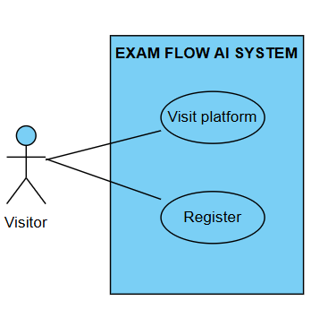
Figure 7: Use Case Diagram Visitor side

Student / Teacher side
Figure 8 illustrates the Sprint 1 use case diagram for the authenticated user side, where users can log in, manage their profile, and reset their password.
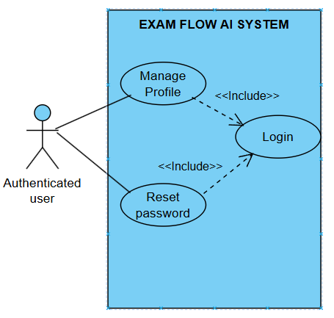
Figure 8: Use Case Diagram Authenticated user side

Admin side
Figure 9 illustrates the Sprint 1 use case diagram for the admin side, where the administrator can manage users, view statistics, verify roles, and ban or unban users.
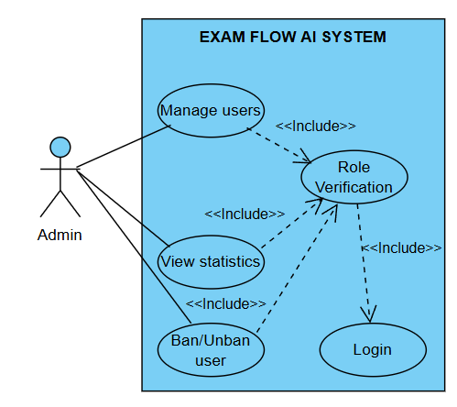
Figure 9: Use Case Diagram Admin side

Sequence Diagrams
This sequence diagram illustrates the user registration workflow, including form submission, password hashing, user creation, JWT generation, and redirection after successful authentication.
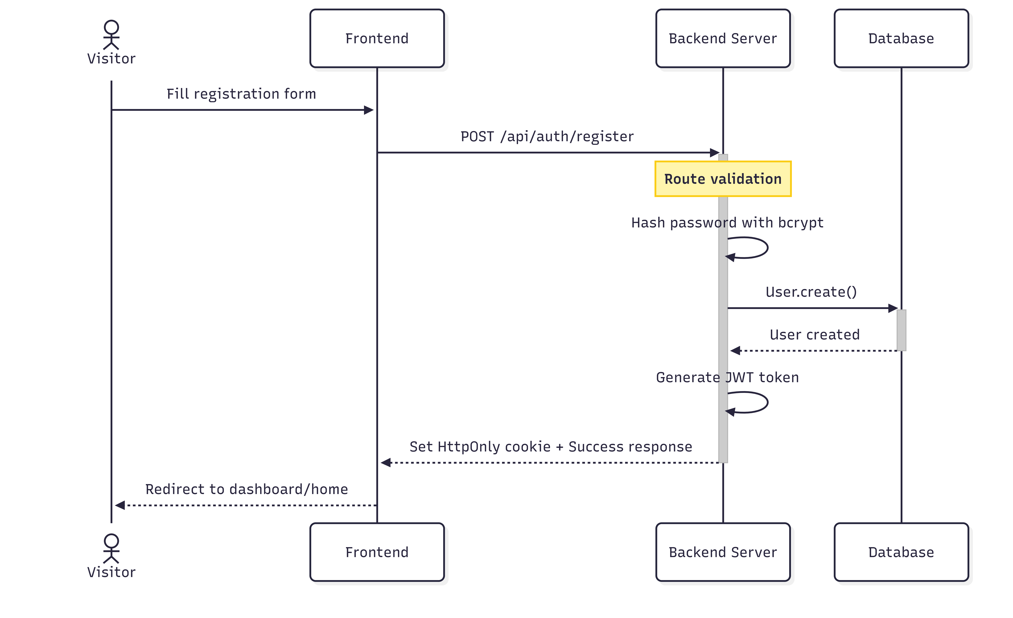
Figure 10 : Sequence Diagram « Register account »
This sequence diagram describes the login process with credential verification, JWT issuance on success, and error handling for invalid credentials.
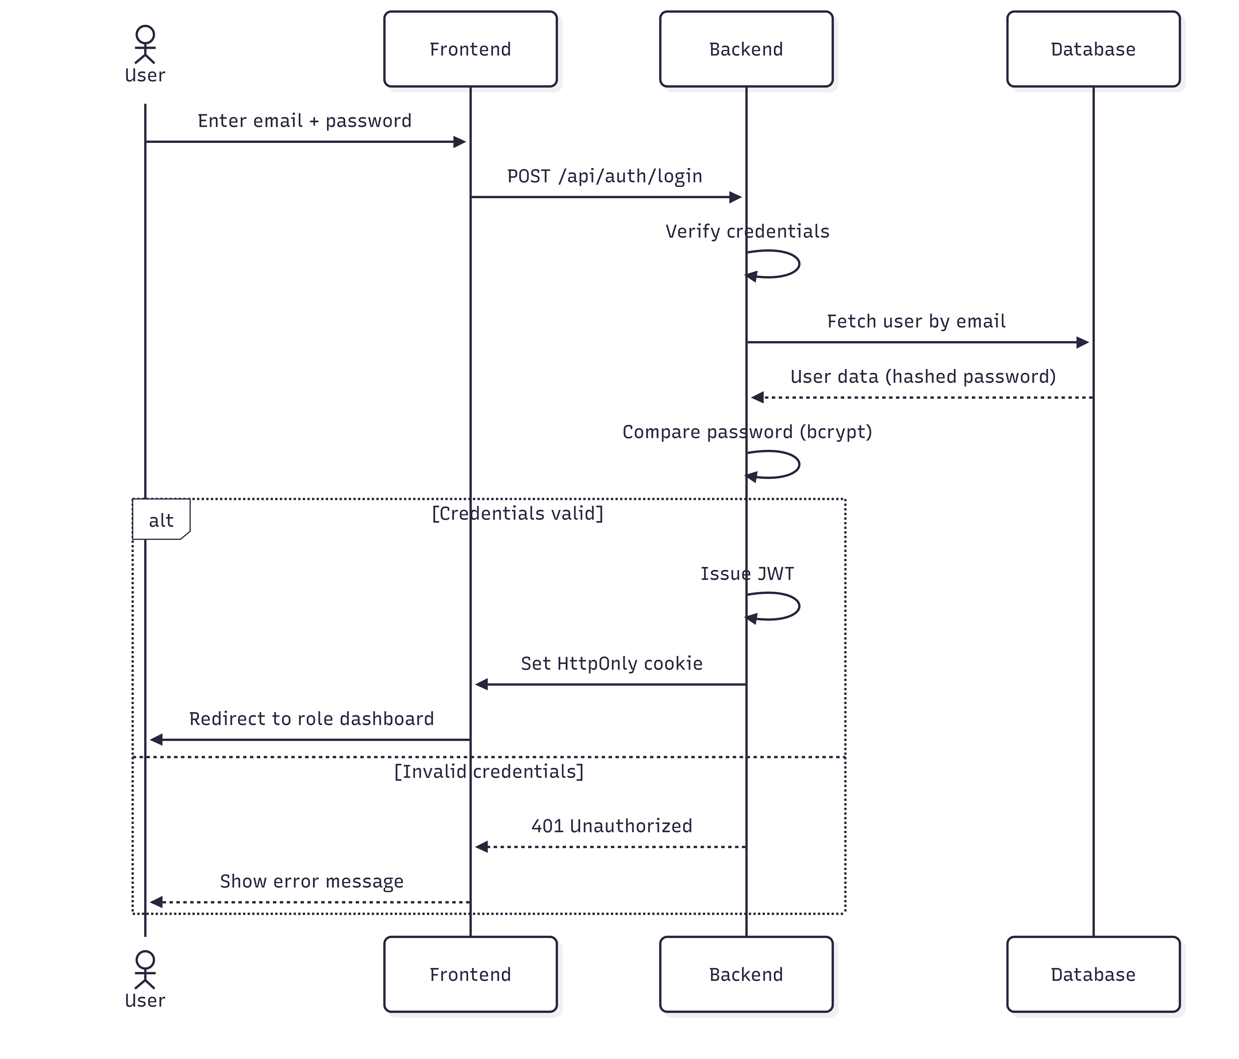
Figure 11 : Sequence Diagram « Login »
This sequence diagram shows the password reset process with token generation, validation, and password update.

Figure 12 : Sequence Diagram « Reset password »

Class Diagram
This class diagram of Sprint 1 models the User entity and its specialized roles (Admin, Student, Teacher) with inheritance and core authentication-related attributes .
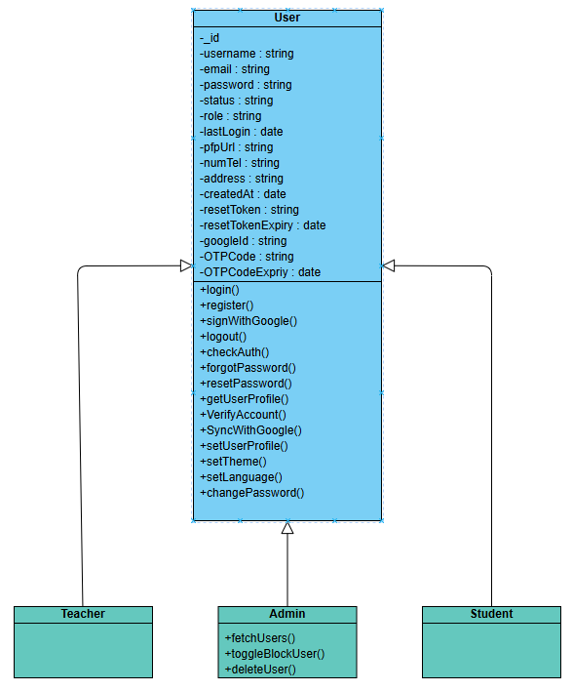
Figure 13 : Class Diagram of Sprint 1

Realization
In this section, we present the interfaces produced during Sprint 1.

Landing page
The Landing Page was implemented as the main entry point of the platform, providing an overview of features and guiding users toward authentication and navigation actions.

Figure 14 : Landing Page

Register Page
The Register Page was implemented to allow new users to create an account securely through form validation and authentication integration.

Figure 15: Register Page

Login Page
The Login Page was developed to authenticate users and redirect them to their respective dashboards based on roles.
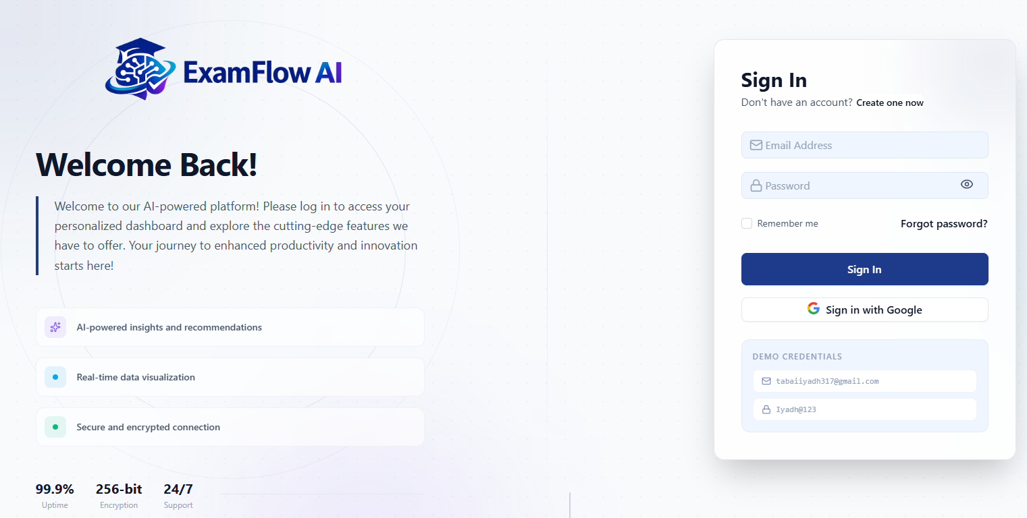
Figure 16: Login Page

Forget & Reset password Pages
The Forget and Reset Password Pages were implemented
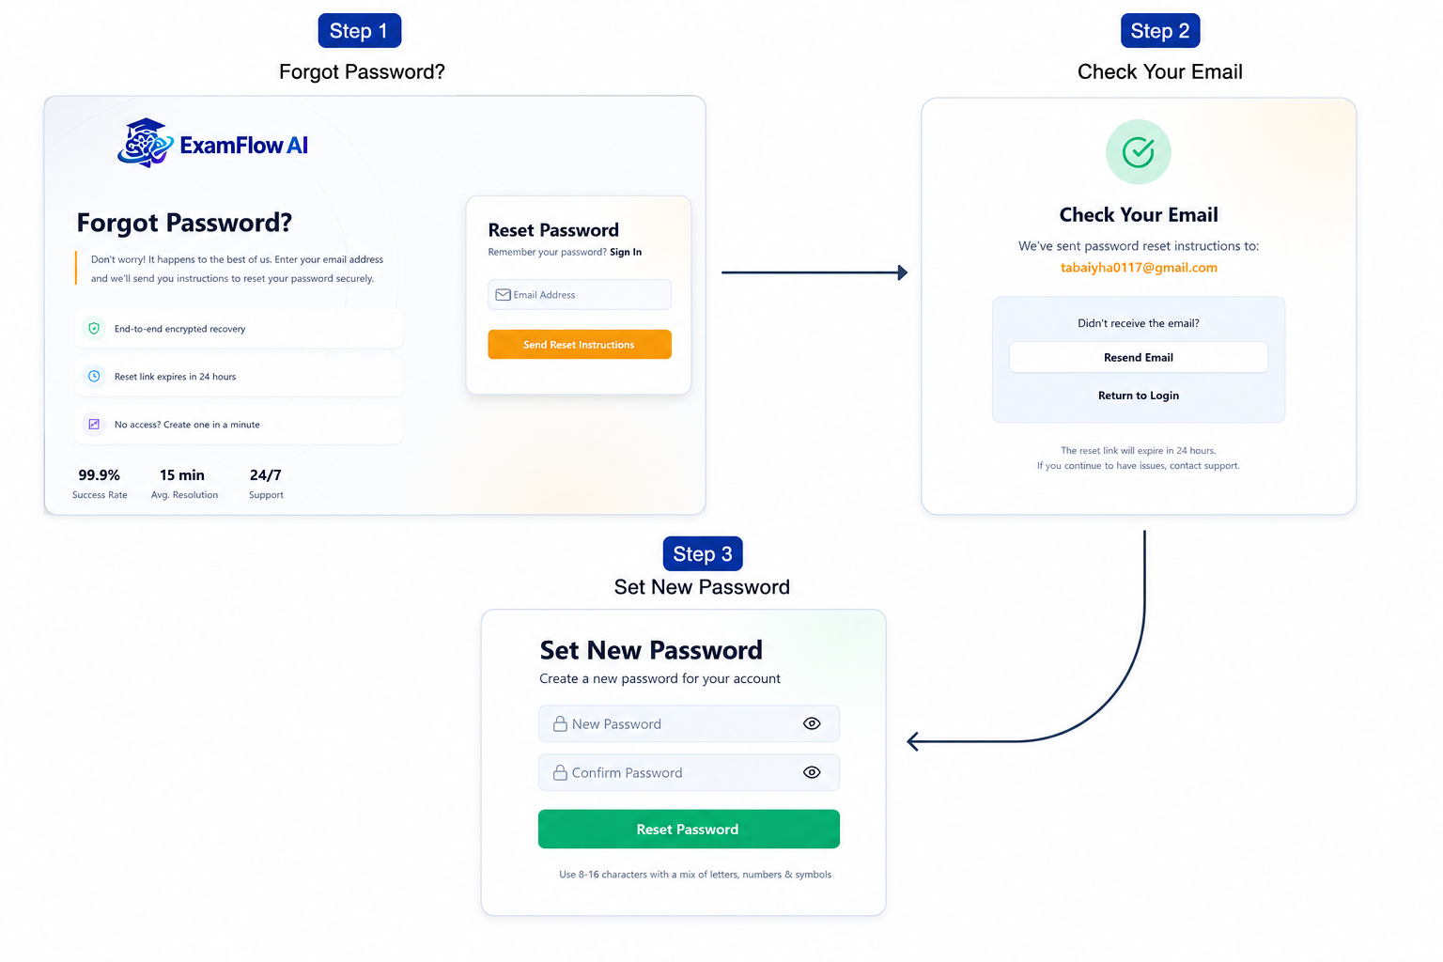
Figure 17 : Forget & Rest password pages

Profile page
The Profile Page was implemented to allow authenticated users to view and manage their personal account information.
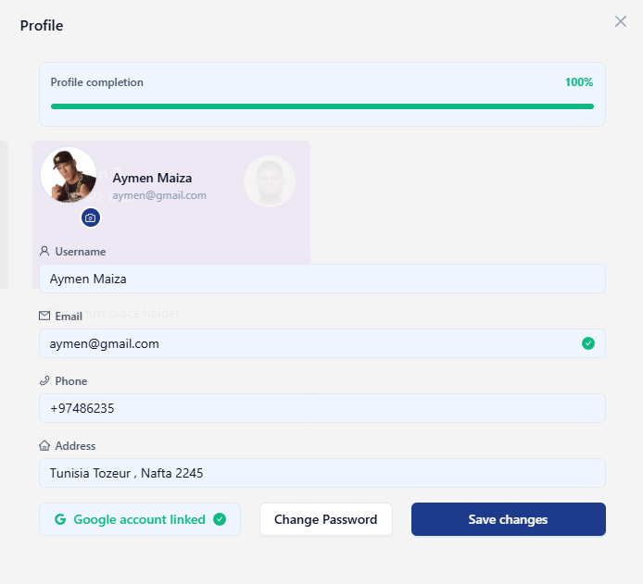
Figure 18: Profile page

Admin dashboard
The Admin Dashboard was implemented to provide KPI statistics visualization and user management functionalities, including role verification and ban/unban actions.
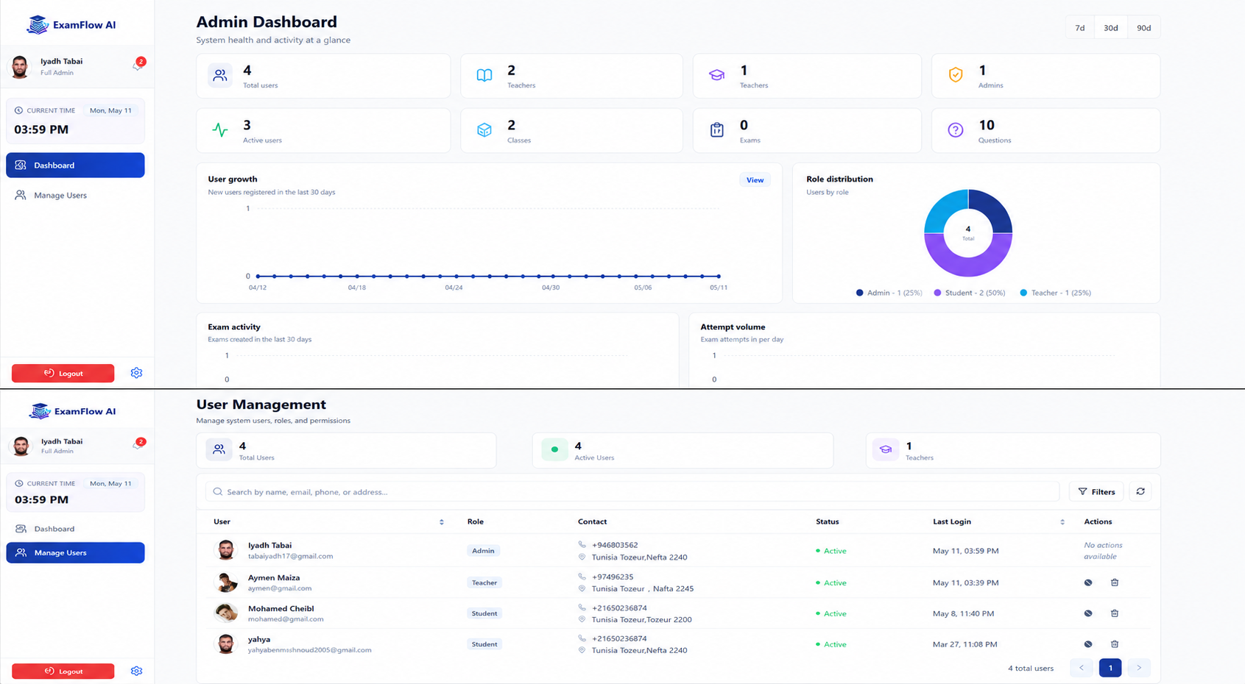
Figure 19: Admin dashboard

Student dashboard
The Student Dashboard was implemented to provide students with an overview of their activities, resources, and platform interactions.
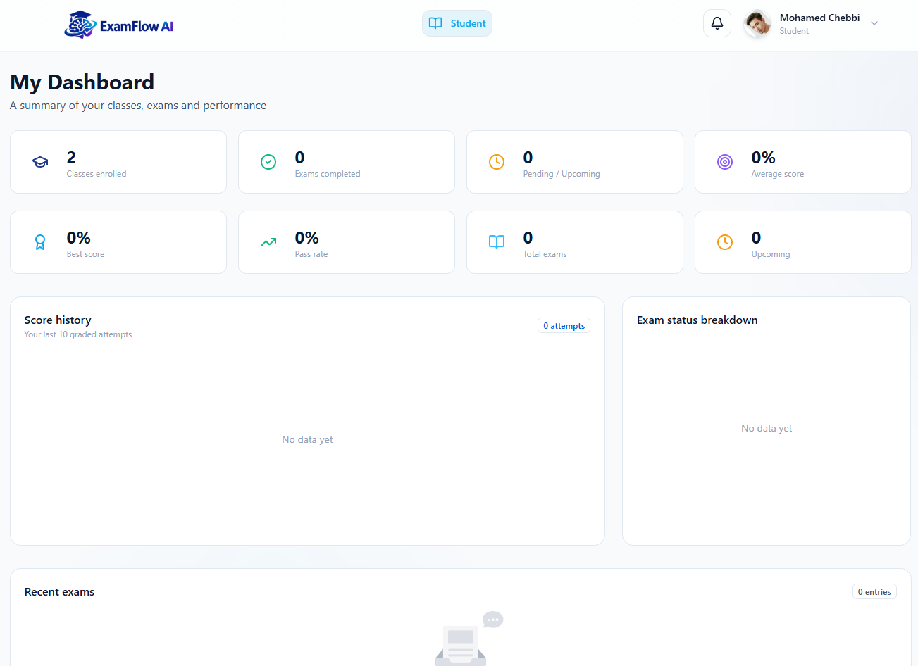
Figure 20: Student Dashboard Page

Teacher dashboard
The Teacher Dashboard was implemented to allow teachers to manage their content, monitor students, and access relevant academic tools.
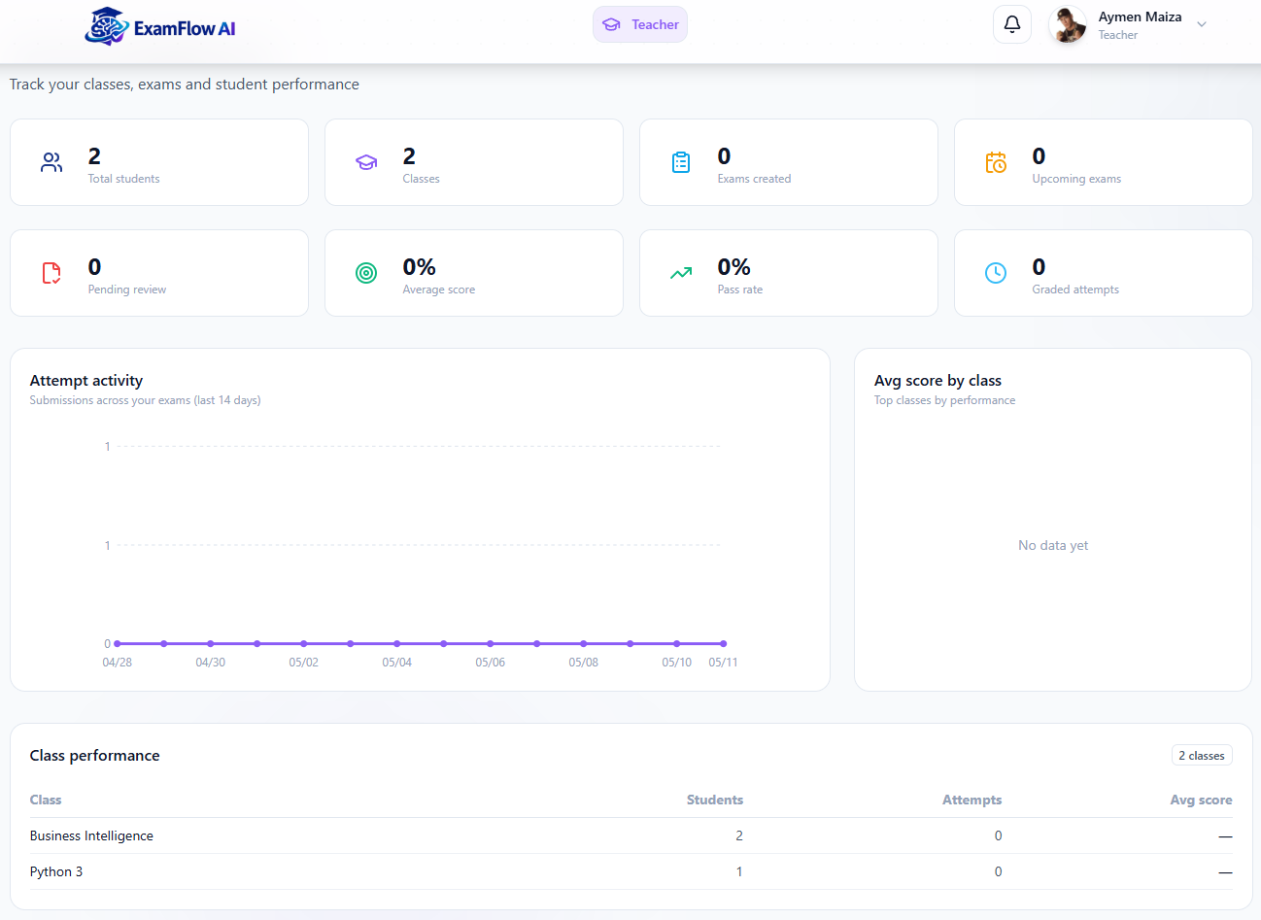
Figure 21: Teacher Dashboard Page

Conclusion
In this chapter, we detailed the first sprint of our project, which focused on implementing authentication, profile management, password reset, and the admin foundation
(user management + global stats). The next chapter presents the progress of the second sprint.

Chapitre | Sprint 2 : Classes, Course Materials, and File Upload
4

Chapitre

Sprint 2 : Classes, Course Materials, and File Upload

Introduction
After establishing the foundational features in Sprint 1 (authentication, profile, admin), this chapter marks a new phase in the development of our platform: the realization of the second increment, focused on the Class / Course / File management features that prepare the ground for AI question generation in Sprint 3.

Sprint Objectives
This second sprint enriches the application with features tailored for Teachers and Students, focusing on class management, course organization, and content access.
- For Teachers:
Teachers can create and manage classes with a title, subtitle, color, and description. They define courses with a level (Beginner / Intermediate / Advanced) and structured markdownContent[]. They can also upload course materials (PDF, DOCX), tracked through a processing status (pending / processing / converted / error), and approve student join requests.
- For Students:
Students can send join requests to classes (stored in Class.sentRequests[] and Student.requests[]) and, once accepted, view their classes and access uploaded course materials.
- Cloud Integration:
Cloudinary is used for file storage, with each file referenced via File.public_id and File.webViewLink.

Sprint 2 Backlog
Table 13: Sprint 2 Backlog
PBI | Functionality | US Code | User Story | Task ID | Tasks
Teacher
12 | Manage classes | US12.1 | As a teacher, I want to create a new class in order to organize my courses and students in one place. | 12.1 | Build TeacherPage.jsx with ClassModal.jsx and ClassComp.jsx.
 |  |  |  | 12.2 | Implement Class schema (title, subtitle, color, description, teacher → Teacher, courses[] → Course, students[] → Student, files[] → File, sentRequests[] → Student).
 |  |  |  | 12.3 | Develop POST /api/class and GET /api/class.
 |  | US12.2 | As a teacher, I want to edit or delete a class in order to keep my class list accurate and up to date. | 12.4 | Develop PUT /api/class/:id and DELETE /api/class/:id.
 |  | US12.3 | As a teacher, I want to manage courses inside a class in order to structure the learning content for my students. | 12.5 | Implement Course schema (title, description, level: ['Beginner','Intermediate','Advanced'], image, markdownContent[]).
 |  |  |  | 12.6 | Develop /api/course CRUD endpoints.
13 | Upload course materials | US13.1 | As a teacher, I want to upload PDF and DOCX course materials in order to share resources with my students. | 13.1 | Build DriveFilesModal.jsx (drag-drop).
 |  |  |  | 13.2 | Wire Multer + Cloudinary upload (store public_id, webViewLink).
 |  |  |  | 13.3 | Develop /api/file upload endpoints (associate to course).
 |  |  |  | 13.4 | Implement File schema (name, mimeType, modifiedTime, size, status: ['pending','processing','converted','error'], webViewLink, public_id, course → Course).
 |  |  |  | 13.5 | Display uploaded files with download links and conversion status.
Student
6 | Join a class | US6.1 | As a student, I want to send a join request to a class in order to access its courses and materials. | 6.1 | Build "Request to join" UI in student dashboard.
 |  |  |  | 6.2 | Develop /api/student/requests to push class id into Student.requests[] and Class.sentRequests[].
 |  | US6.2 | As a teacher, I want to accept or reject join requests in order to control who can access my class. | 6.3 | Teacher accepts/rejects → moves student into Class.students[] and into Student.classes[].
 |  |  |  | 6.4 | Notification on successful join (Notification model).
 |  |  |  | 6.5 | Display student's classes on dashboard.

Design

Use Case Diagrams

Teacher side
Manage classes (create, edit, delete), manage courses, upload course materials, and invite students.
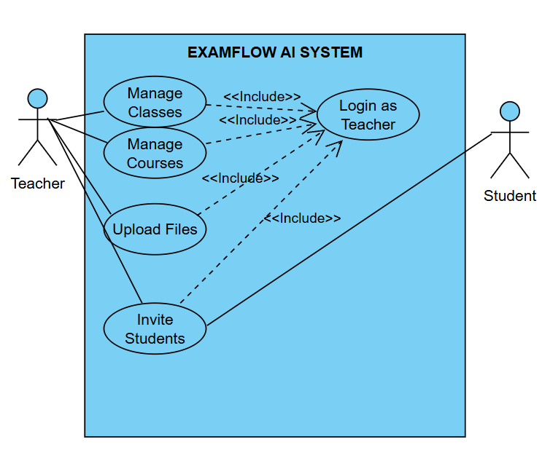
Figure 22 : Use Case Diagram Teacher side

Student side
Join classes, view enrolled classes, and access/download course materials.
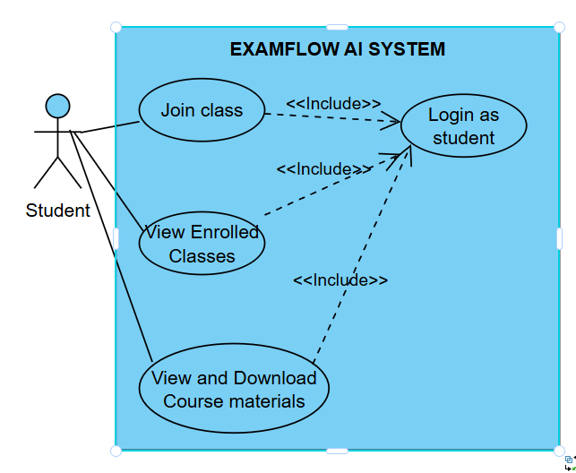
Figure 23: Use Case Diagram Student side

Sequence Diagrams
The teacher submits the class creation form, the frontend sends a POST request to /api/classes, the backend stores the class in MongoDB, generates the class code, then returns and displays the created class information.

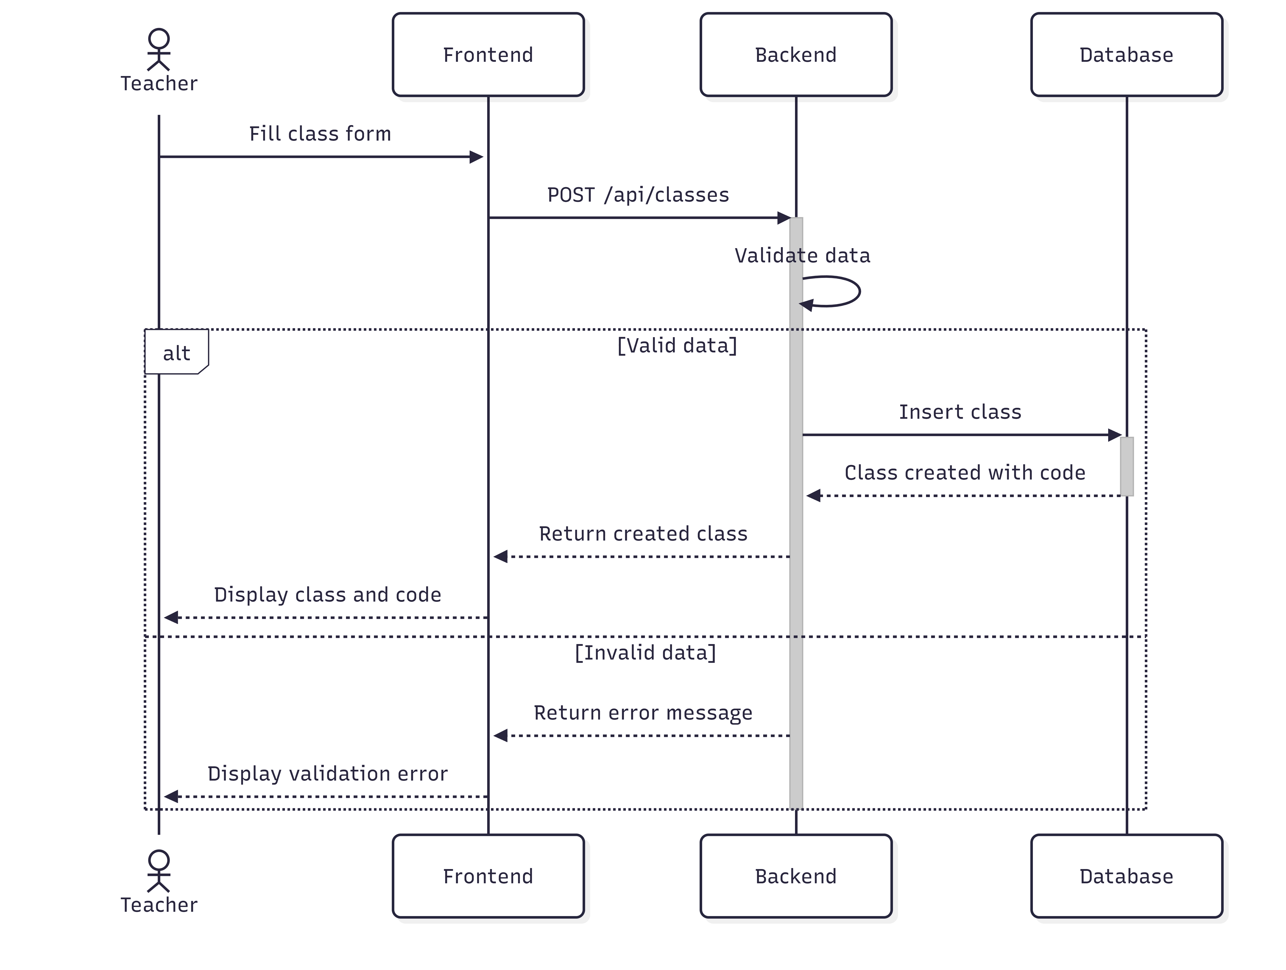
Figure 24 : Sequence Diagram « Create a class »

The teacher selects a file, the frontend sends it as a multipart form, Multer processes the upload, the file is stored in Cloudinary, the file metadata is saved in MongoDB, and a success response is returned.
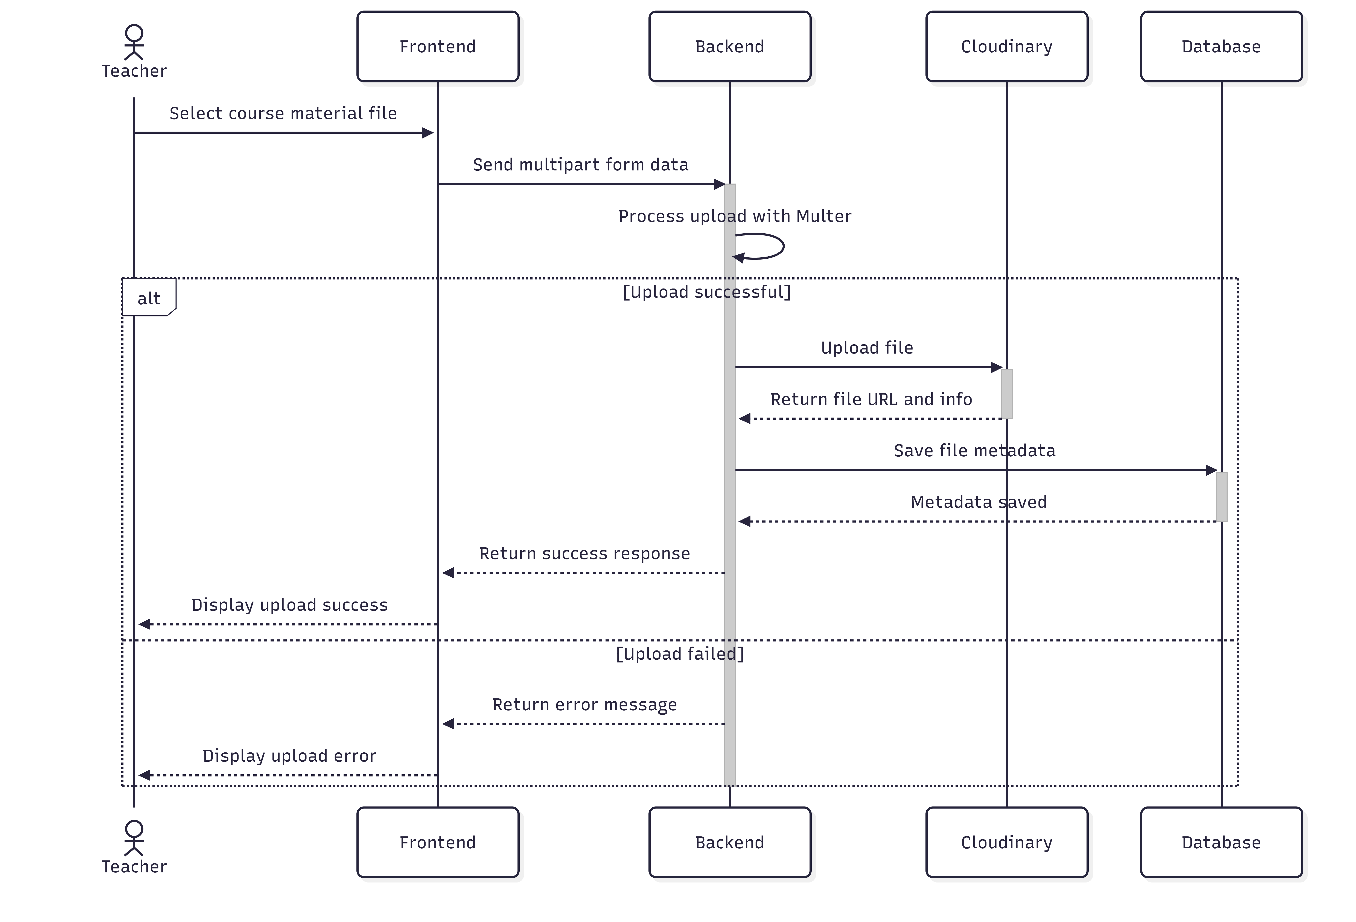
Figure 25: Sequence Diagram « Upload a course material »

Activity Diagrams
The student enters a class code, the system sends a POST request to /api/classes/join, validates the code, checks existing membership, adds the student to the class, notifies the teacher, and refreshes the student dashboard.
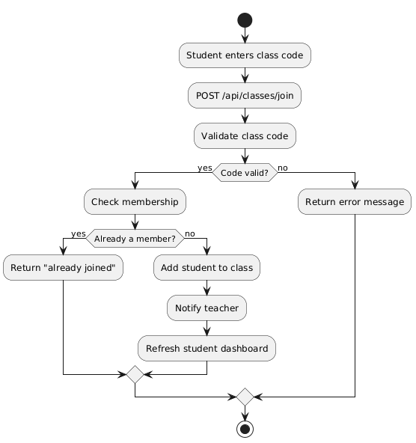
Figure 26 : Activity Diagram « Join a class »
The student enters a class code, the system sends a POST request to /api/classes/join, validates the code, checks existing membership, adds the student to the class, notifies the teacher, and refreshes the student dashboard.

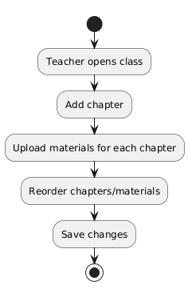
Figure 27: Activity Diagram « Manage course chapters »

Class Diagram
Class, Course, File, MarkdownContent, and Progress entities with relationships for class management (create, join, update, delete), file handling, course enrollment, content management, and student progress tracking.

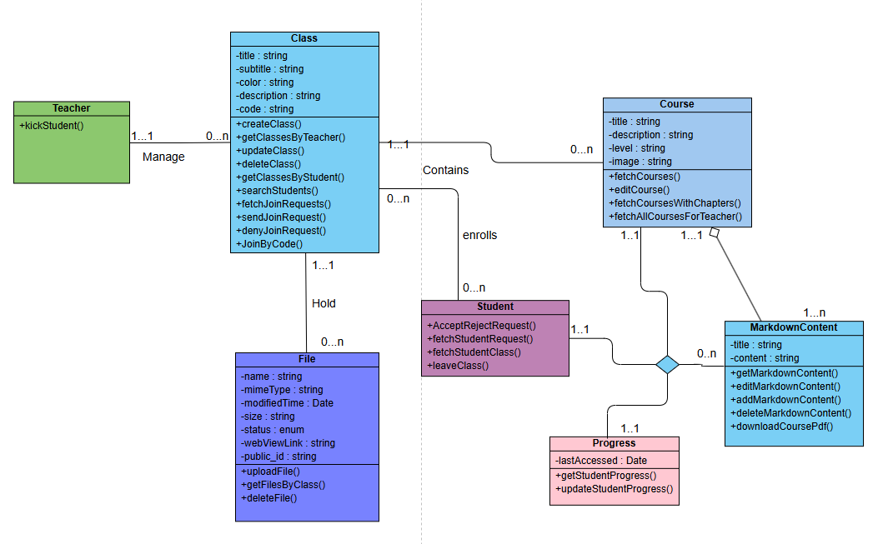
Figure 28: Class Diagram of Sprint 2

Realization

Teacher dashboard — Class management
Allows teachers to create, edit, and manage their classes and course structure from a centralized dashboard.
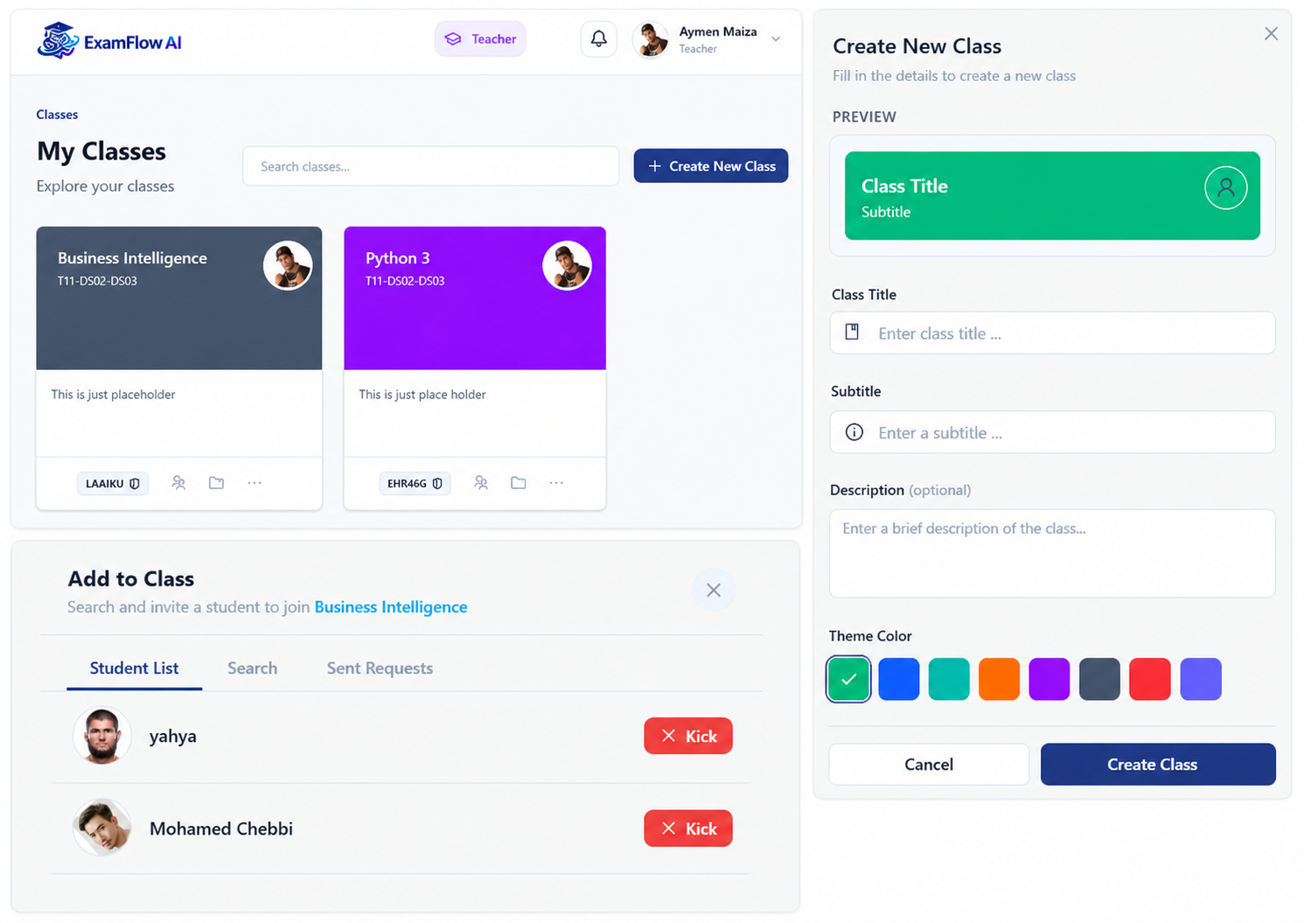
Figure 29: Class management

Course materials modal (Drive Files)
Displays uploaded course materials and provides access to cloud-stored files through an organized modal interface.
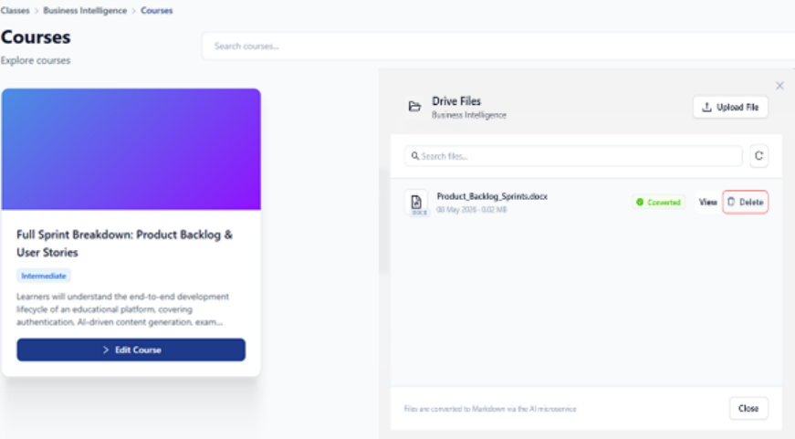
Figure 30 : Meta Course & Drive files

Student dashboard Joining a class
Enables students to join classes using a class code and view their enrolled classes and materials.

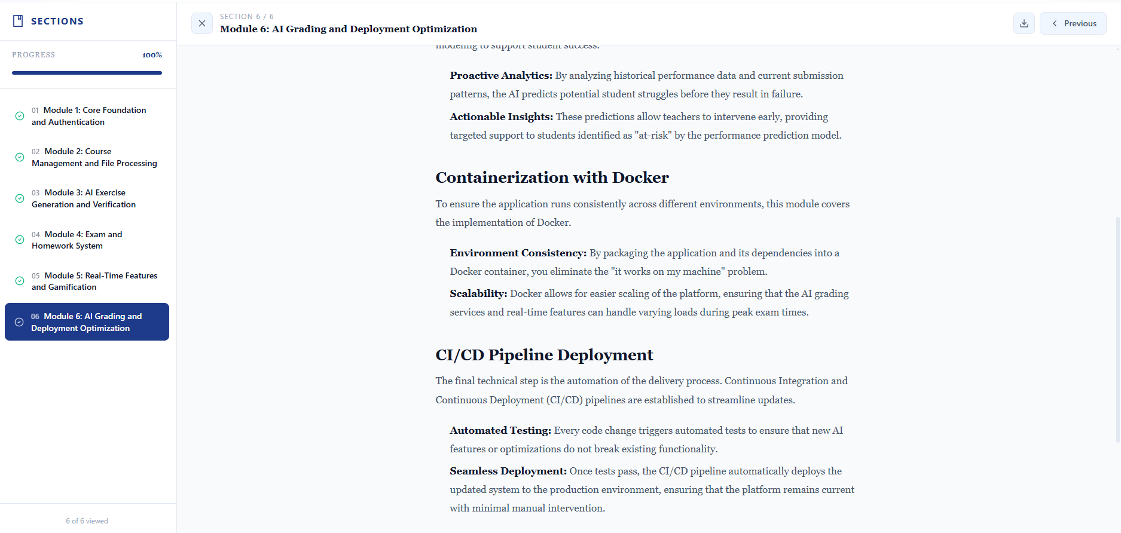
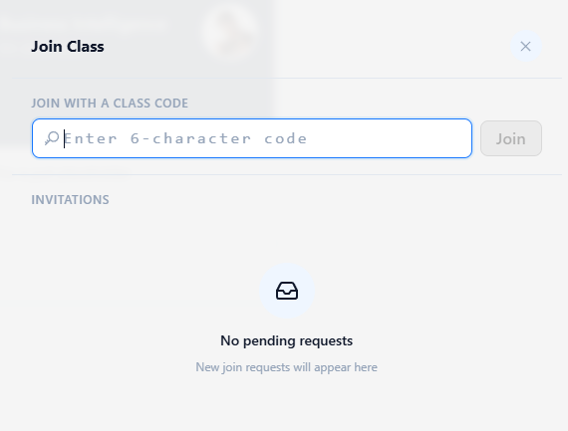
Figure 31: Joining a class & Show course material

Conclusion
During this sprint, we elaborated the Sprint Backlog, designed the corresponding UML diagrams, and demonstrated the realized interfaces. The class, course, and file-upload features now form a solid base for the AI-driven question generation that Sprint 3 will introduce.

Chapitre | Sprint 3 : AI Engine , Question Bank , and Assiste Review
5

Chapitre

Sprint 3 : AI Engine , Question Bank , and Assiste Review

Introduction
Following the development of class and file-management features in Sprint 2, we now address the core differentiating value of EXAMFLOW AI: the AI engine that generates exam questions from raw course materials, and the question bank that allows teachers to curate, edit, and reuse those questions.
This sprint focuses on transforming uploaded educational content into structured, meaningful assessment materials, enabling teachers to significantly reduce the time and effort required to design exams.

Sprint Objectives
The third sprint focuses on extending the platform with artificial intelligence features powered by a dedicated FastAPI microservice:
- Process uploaded PDFs / DOCX through document conversion (file_service.extract_text + convert_ai_service to generate course meta, section plans, and full section markdown content).
- Chunk the extracted text with RecursiveCharacterTextSplitter (chunk size = 1000 chars, overlap = 150 chars) and index it into Qdrant with Gemini embeddings (gemini-embedding-2).
- Generate structured questions (single_answer, multiple_answer, short_answer) using Google Gemini LLM (gemini-3.1-flash-lite-preview), with course/chapter awareness, difficulty calibration (easy / medium / hard), language and Bloom's-level controls, and custom instructions.
- Build a question bank with CRUD, filters (by class, course, chapter, difficulty, type, source manual vs ai), and validators (numeric correct answer for single, array for multiple, non-empty string for short).
- Provide AI-assisted short-answer review to support teachers during manual grading.

Sprint 3 Backlog
Table 24 : Sprint 3 Backlog
PBI | Functionality | US Code | User Story | Task ID | Tasks
14 | Convert documents | US14.1 | As a teacher, I want to convert uploaded files into structured Markdown format, so that I can organize, process, and reuse course content more effectively. | 14.1 | Build file_service.extract_text (PyPDF / docx).
 |  |  |  | 14.2 | Build convert_ai_service.py (generate_course_meta, generate_section_plan, generate_section_content).
 |  |  |  | 14.3 | Expose /upload and /convert endpoints on FastAPI.
 |  |  |  | 14.4 | Update File.status (pending → processing → converted or error) on the server side.
 |  |  |  | 14.5 | Persist MarkdownContent in Mongo and link it to Course.markdownContent[].
15 | Generate questions | US15.1 | As a teacher, I want the system to use RAG and an LLM to generate questions from course materials, so that I can quickly create relevant and context-aware exam questions. | 15.1 | Build vector_service.py (Qdrant + Gemini embeddings: store_text_chunks, get_chunks_by_source, delete_source, backfill_payload).
 |  |  |  | 15.2 | Build generate_question_ai_service.py with prompt template, JSON schema, retries.
 |  |  |  | 15.3 | Expose POST /generate-questions on FastAPI.
 |  |  |  | 15.4 | Server endpoint POST /api/questions/generate (and /generate/preview) protected by authorizeRoles("teacher").
 |  |  |  | 15.5 | Wire teacher UI GenerateQuestions.jsx + GenerationProgress.jsx + GeneratedPreview.jsx.
 |  |  |  | 15.6 | Persist questions in Question collection with source: "ai" and vectorSource link.
16 | Question bank | US16.1 | As a teacher, I want to view a list of generated questions, so that I can review, select, and manage questions for assessments. | 16.1 | Build QuestionBankPage.jsx.
 |  |  |  | 16.2 | Develop GET /api/questions (filters + pagination).
 |  |  |  | 16.3 | QuestionFiltersSidebar.jsx for class / course / chapter / difficulty etc
 |  | US16.2 | As a teacher, I want to verify, edit, or delete generated questions, so that I can ensure the question bank is accurate, relevant, and high quality before using it in exams. | 16.4 | Build QuestionPreviewModal.jsx.
 |  |  |  | 16.5 | Develop POST /api/questions/verify, POST/PUT/DELETE /api/questions[/:id].
 |  |  |  | 16.6 | Pre-save normalization: correctAnswer cast to Number for single_answer, array of Number for multiple_answer.
19 | AI-assisted review | US19.1 | As a teacher, I want to receive scoring suggestions for short-answer questions, so that I can grade more consistently and efficiently while maintaining fair evaluation standards. | 19.1 | Build review_short_answer_ai_service.py (Gemini LLM).
 |  |  |  | 19.2 | Expose POST /review-short-answer.
 |  |  |  | 19.3 | Display AI score + rationale on ExamReviewPanel.jsx; teacher overrides via PUT /api/exam-attempts/:attemptId/grade.

Design

Use Case Diagrams
use case diagram covering document conversion, AI question generation, question bank management (filtering, editing, approval, deletion), and AI-assisted review of student submissions.
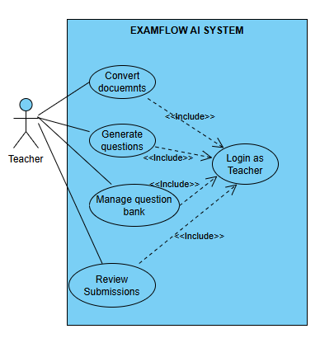
Figure 32: Use Case Diagram of Teacher side

Sequence Diagrams

Sequence diagram illustrating the end-to-end flow of generating exam questions from a selected document, from teacher request through frontend, backend, AI service, vector search, LLM generation, persistence, and final preview display.

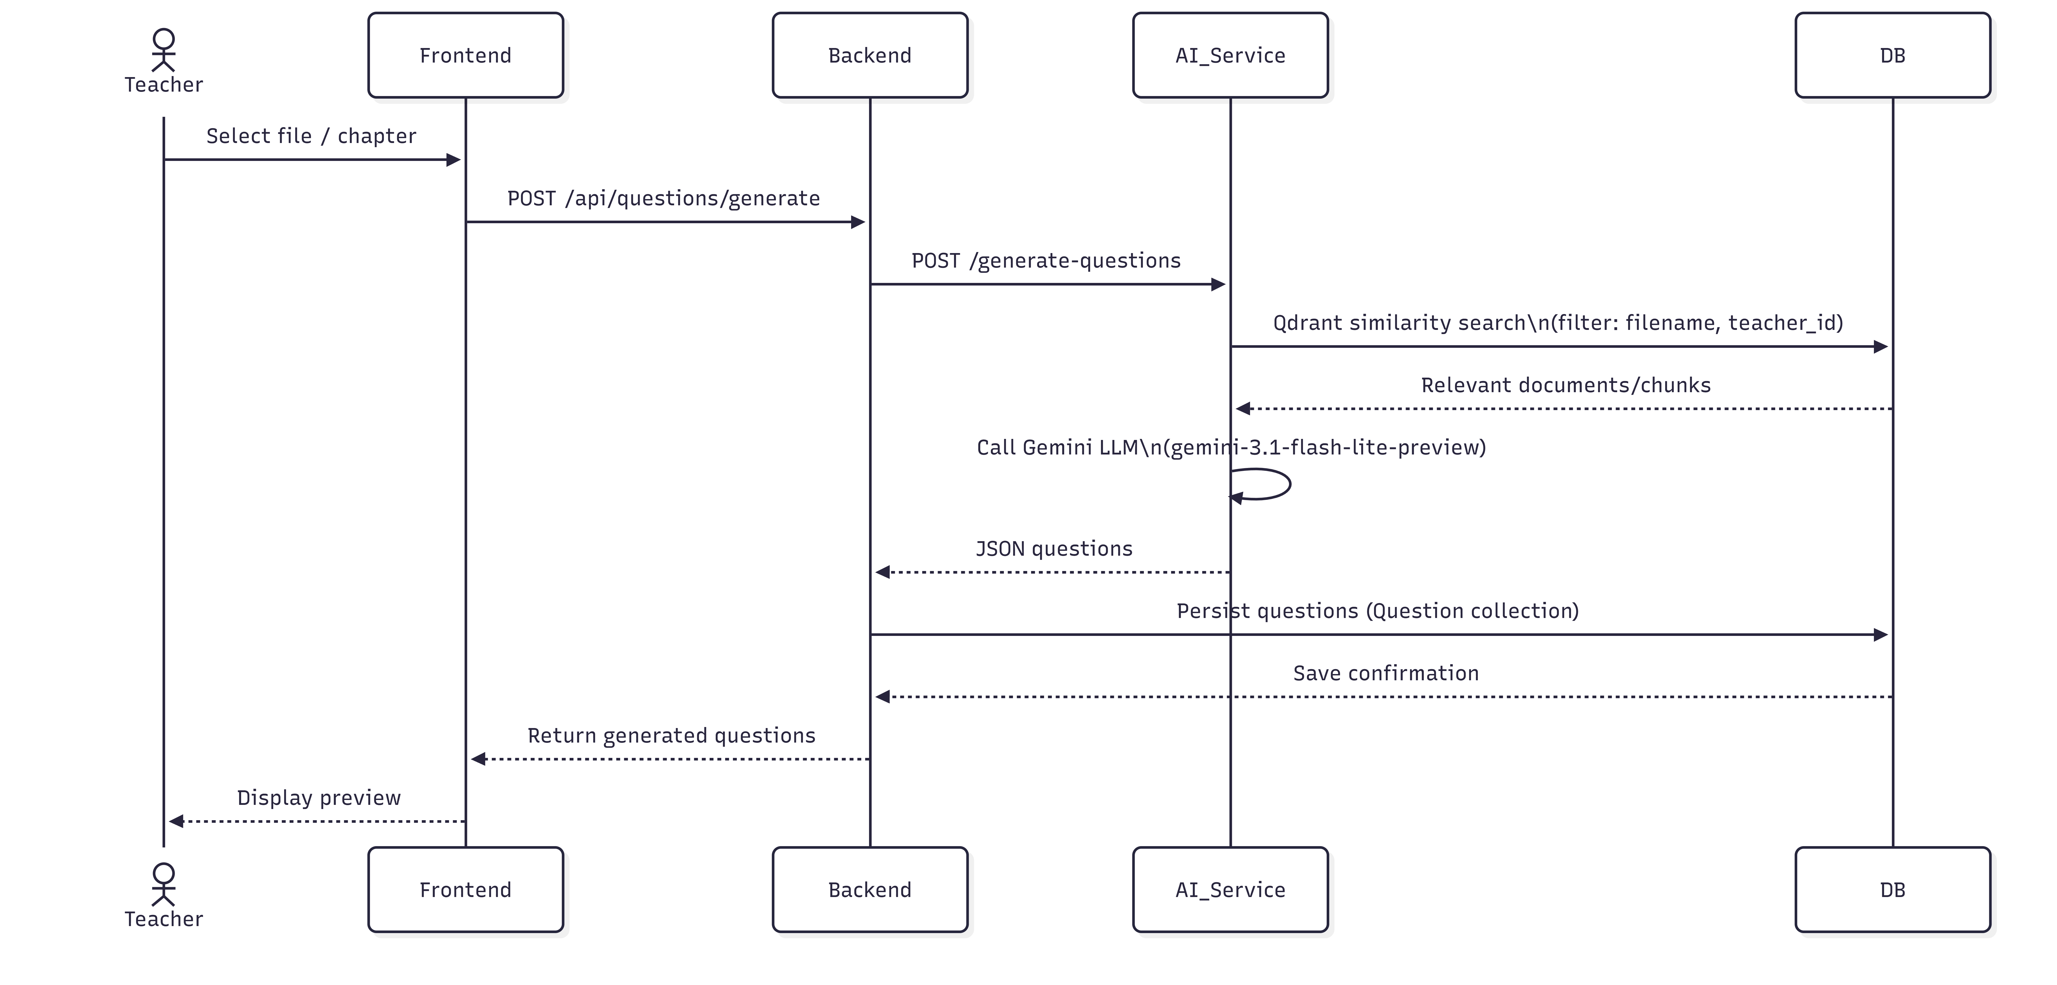
Figure 33: Sequence Diagram « Generate questions from a document »

Sequence diagram illustrating the process where a teacher approves a generated question, triggering an API request to update its status to “approved” in the database, followed by a refreshed question list in the frontend.

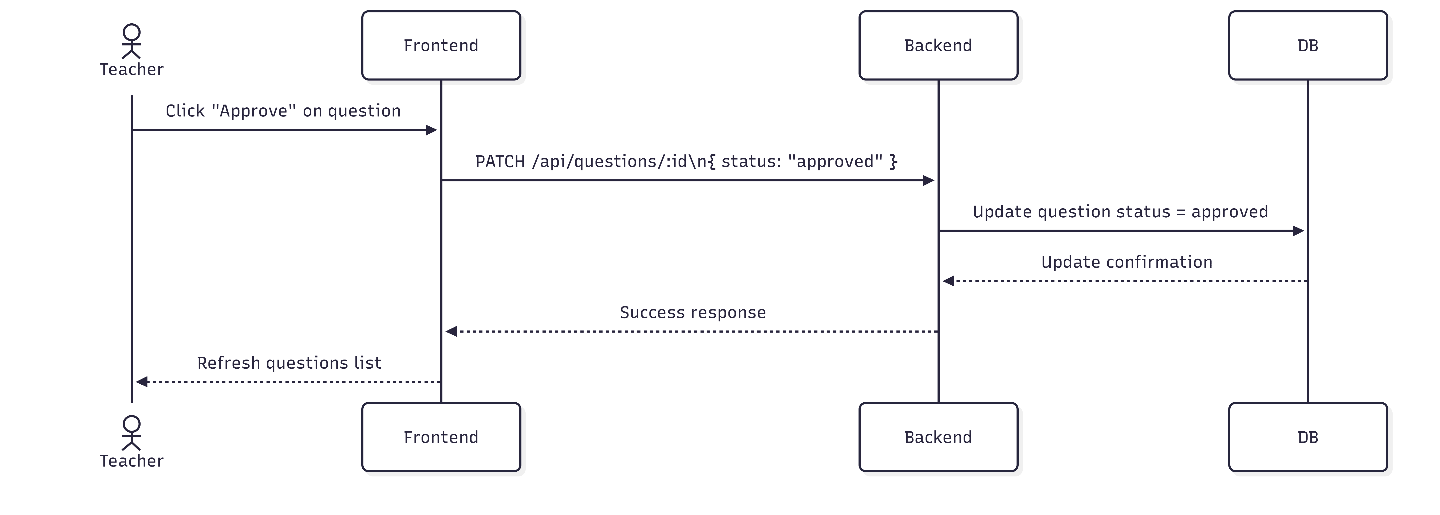
Figure 34: Sequence Diagram « Approve a generated question »

Activity Diagrams
Activity diagram illustrating the pipeline for converting uploaded documents into markdown, generating embeddings, indexing them in Qdrant, and storing the processed content in MongoDB.
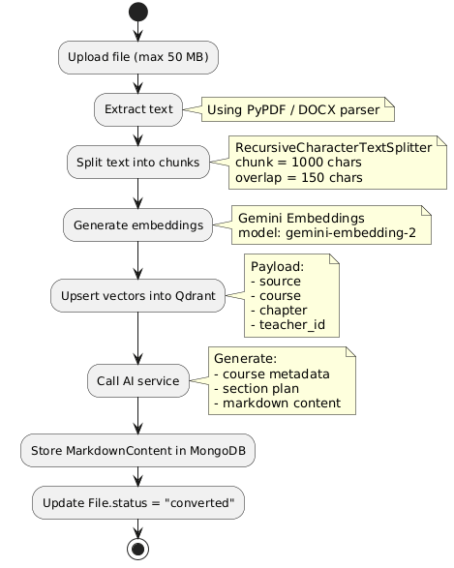
Figure 35: Activity Diagram « Convert PDF to markdown and index in vector DB »
Activity diagram showing how a teacher reviews short answers using AI-generated scoring and comments, with the option to accept or override the suggestion.
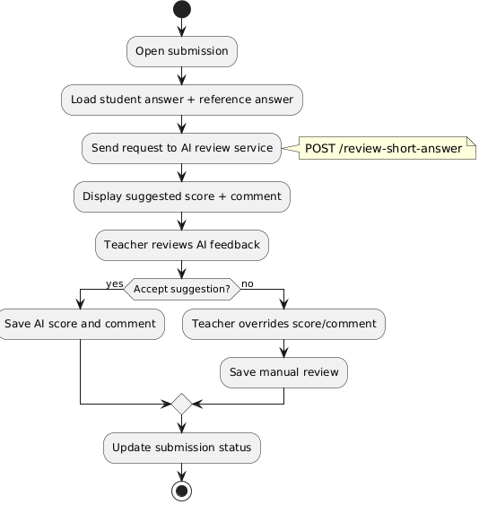
Figure 36: Activity Diagram « AI-assisted short-answer review »

Class Diagram
Class diagram representing Sprint 3 data models and AI services responsible for document conversion, vector indexing, question generation, and short-answer evaluation.
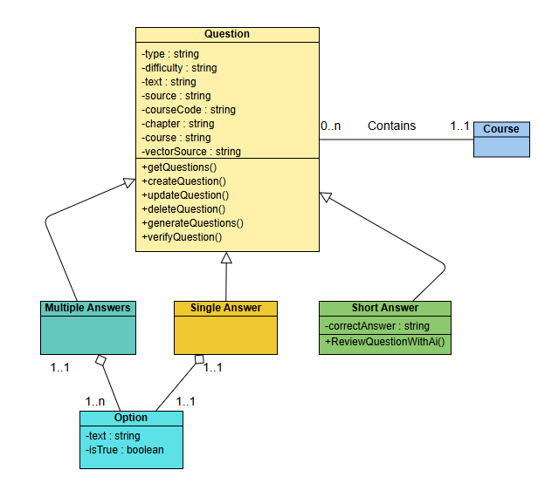
Figure 37: Class Diagram of Sprint 3

Realization

Question generation flow
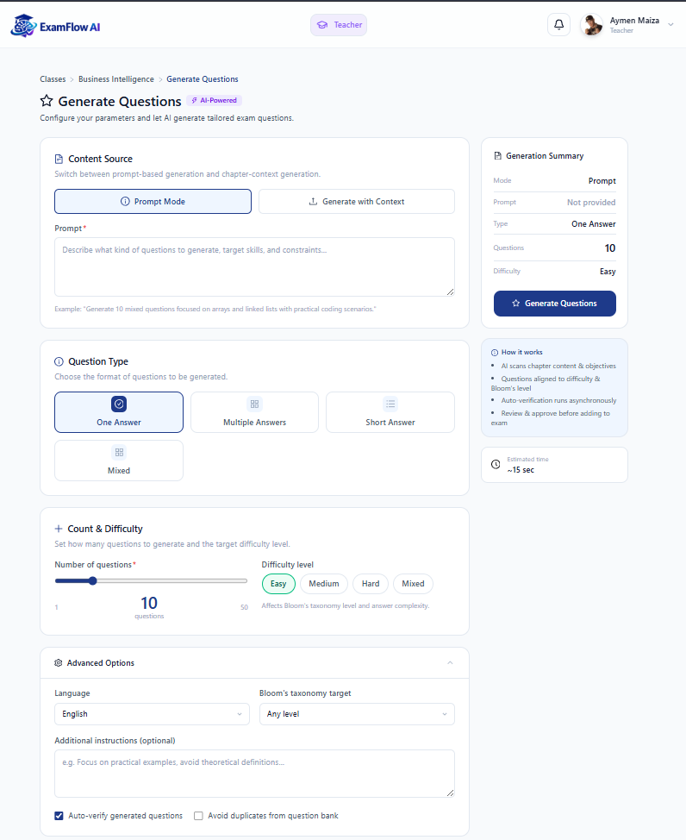
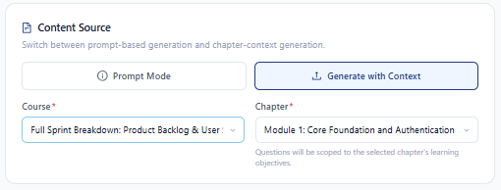
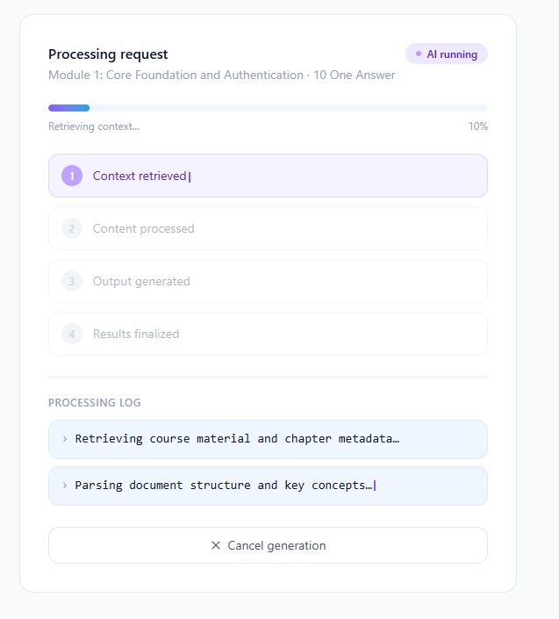

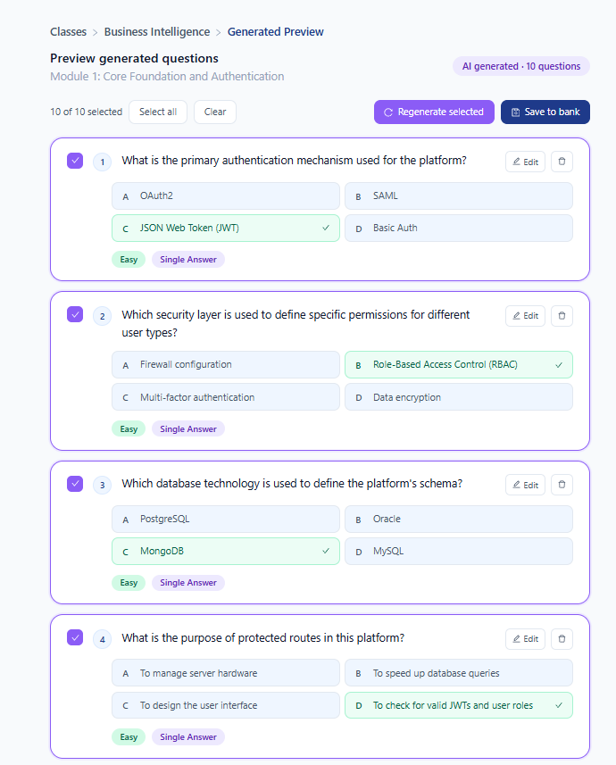

Question bank
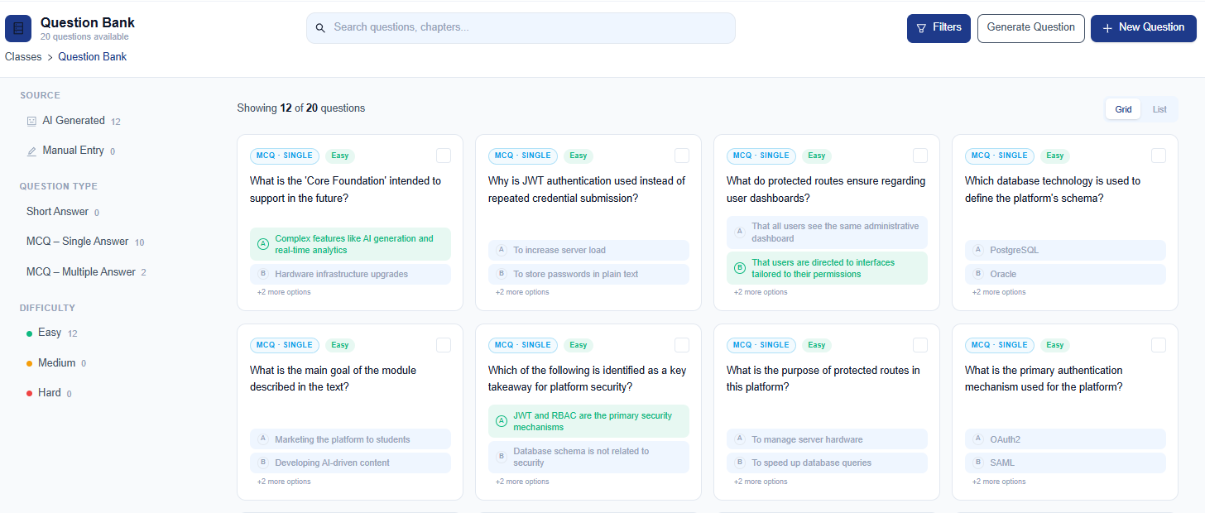
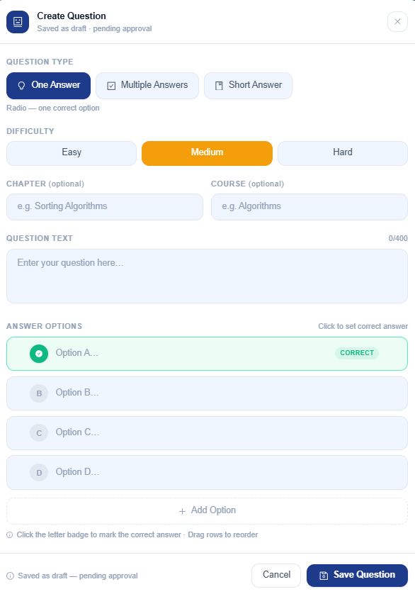

AI-assisted short-answer review

Conclusion

Conclusion Générale

La conclusion générale dresse le bilan global du projet, en évaluant les résultats obtenus et en ouvrant sur les perspectives futures.

- Synthétisez les travaux réalisés et les principales contributions
- Évaluez l'atteinte des objectifs initiaux de façon critique et objective
- Discutez des apports du projet pour l'organisme d'accueil
- Identifiez les limites actuelles de la solution développée
- Proposez des perspectives d'amélioration et d'extension à court et moyen terme
- Présentez les enseignements personnels et professionnels tirés de cette expérience
- Terminez par une ouverture sur les évolutions possibles du domaine à plus long terme

Bibliographie

Adoptez la nomenclature suivante :
[1] : Nom de l’auteur Première lettre du prénom de l’auteur. ‘Titre’, Edition, Année d’édition, pages.
[2] : www.nomsite/repertoire/..../page.extension, date accès

Exemple :
[1] : Bakos J., ‘Information technologique’, MIS Quarterly, juin 1998, p.196-198.
[2] : www.isett.rnu.tn/fr/actualites.asp, 19/12/2008

Remarque : La bibliographie doit être classée par ordre alphabétique et tout objet figurant dans la liste bibliographique doit être référencé au moins une fois dans l’une des sections du rapport.

Annexe A : Titre de l’annexe

L’annexe (ou annexes, au pluriel) sert à fournir des informations complémentaires qui seraient trop longues, trop techniques ou trop détaillées pour être incluses directement dans le corps du rapport. Elle permet de ne pas alourdir le texte principal tout en offrant au lecteur la possibilité d’aller plus loin s’il le souhaite.

Exemples d’éléments placés en annexe :
- Questionnaires utilisés dans une enquête
- Code source (extrait de script, programme, configuration)
- Tableaux de données détaillées
- Captures d’écran d’une interface
- Résultats d’expériences complètes
- Spécifications techniques
- Diagrammes supplémentaires

Utiliser ce cadre pour introduire le code ou script si vous en ai besoin

Avec le police (Courier New) : exemple
<ul class="navbar">
<li><a href="index.html">Home page</a>
<li><a href="reflexions.html">Réflexions</a>
<li><a href="ville.html">Ma ville</a>
<li><a href="liens.html">Liens</a>
</ul>

Consignes aux étudiants

Cette partie donne des consignes à respecter pour garantir la qualité et l’homogénéité des rapports de stage.

Elaboration du rapport
- Planifiez votre rédaction : Commencez tôt et établissez un calendrier
- Soignez la présentation : Mise en page cohérente, pagination, en-têtes/pieds de page, etc
- Validez régulièrement : Soumettez des versions intermédiaires à votre encadrant.

Mise en page
  - Format A4, interligne 1,5
  - Police : Times New Roman 12pt ou Arial 11pt
  - Marges : 2,5 cm de chaque côté
  - Paragraphes justifiés
  - Numérotation des pages

Illustrations
  - Chaque figure/tableau doit être numéroté et titré
  - Toute illustration doit être référencée dans le texte
  - Légende explicative si nécessaire
  - Source mentionnée si l'illustration n'est pas originale

Citations et références
  - Utiliser une norme cohérente (IEEE recommandé pour l'informatique)
  - Chaque citation doit correspondre à une référence bibliographique
  - Toute affirmation non triviale doit être appuyée par une référence
  - Vous pouvez utiliser les notes de bas de page

Typographie

Style Titre de chapitre (Titre 1) : Modern No. 20, 28 pts

Titre de Chapitre

Style Titre 2 : Times New Roman, 16 pts

Section 5 de Chapitre 5

Style Titre 3 : Times New Roman, 14 pts

Sous Section 1 de section 5 de chapitre 5

Erreurs de forme fréquentes à éviter

Fautes d'orthographe et de grammaire
- Exemples fréquents :
  - Accords sujet-verbe incorrects : "Les données est traité" au lieu de "Les données sont traitées"
  - Confusion entre participe passé et infinitif : "Les résultats ont été analyser" au lieu de "analysés"
  - Mauvaise utilisation des sigles : "l'API" et plus loin "la API"
  - Espaces avant/après la ponctuation : "résultat;suivant" au lieu de "résultat ; suivant"
  - Majuscules manquantes aux noms propres : "javascript" au lieu de "JavaScript"
  - Fautes d'accord : "les données collecté" au lieu de "les données collectées"
  - Coquilles : "implémntation", "dévelopement", "progammation"
  - Confusion entre "peut être" et "peut-être", "quelque" et "quel que"
- Impact : Image de négligence, difficultés de lecture, perte de crédibilité
- Solution : Relecture attentive, utilisation de correcteurs orthographiques, relecture par des tiers

Mise en page incohérente
- Exemples fréquents :
  - Polices différentes dans un même paragraphe
  - Tailles de caractères variables pour les titres de même niveau
  - Espacement irrégulier entre les paragraphes
  - Alignement inconsistant (tantôt justifié, tantôt aligné à gauche)
  - Marges différentes d'une page à l'autre
  - Numérotation des chapitres incohérente (1, 1.1, 1.A, 2.i, etc.)
  - Styles d'énumération changeants (puces rondes puis carrées)
  - En-têtes ou pieds de page apparaissant/disparaissant
- Solution : Utiliser systématiquement les styles de document et créer un modèle

Problèmes de références et citations
- Exemples fréquents :
  - Citations sans guillemets ni référence
  - Formats de citation mélangés (APA puis IEEE dans le même document)
  - Références absentes de la bibliographie mais présentes dans le texte
  - Numéros de références désordonnés : [4] apparaît avant [2]
  - Citations trop longues sans reformulation
  - Référence incomplète : "[2]" sans autre information
  - Citations de sources non fiables (blogs personnels, Wikipedia)
  - Format incohérent des URLs dans la bibliographie
- Solution : Utiliser un gestionnaire de références bibliographiques (Zotero, Mendeley)

Problèmes liés aux figures et tableaux
- Exemples fréquents :
  - Figures sans numérotation ni légende
  - Images pixelisées ou trop petites
  - Tableaux coupés entre deux pages sans répétition d'en-tête
  - Absence de référence aux figures dans le texte ("comme on peut le voir...")
  - Figures non sourcées lorsqu'elles sont empruntées
  - Légendes trop vagues ("Résultats obtenus")
  - Tableaux sans unités de mesure spécifiées
  - Diagrammes avec texte illisible
  - Couleurs essentielles à la compréhension mais sans alternative pour impression N&B
- Solution : Vérifier systématiquement chaque figure et tableau, utiliser des formats vectoriels

Problèmes structurels
- Exemples fréquents :
  - Titres seuls en bas de page
  - Paragraphes très courts (1-2 lignes) ou excessivement longs (1 page)
  - Sections déséquilibrées (1 page puis 15 pages)
  - Table des matières non mise à jour après modifications
  - Pages numérotées incorrectement
  - Renvois internes erronés ("voir section 3.2" qui n'existe pas)
  - Listes de puces ou numérotées mal alignées
  - Sauts de section inappropriés créant des pages blanches
  - Annexes sans référence dans le corps du texte
- Solution : Utiliser les fonctionnalités avancées du traitement de texte, vérifier les renvois

Problèmes de style et de ton
- Exemples fréquents :
  - Mélange de style formel et informel ("Cette architecture est trop cool")
  - Utilisation du "je" et du "nous" dans le même paragraphe
  - Formulations familières ("on a codé", "ça marche bien")
  - Ton publicitaire exagéré ("solution révolutionnaire", "parfaitement optimale")
  - Abus de superlatifs ("extrêmement", "incroyablement")
  - Usage inapproprié d'émoticônes ou d'abréviations (LOL, etc.)
  - Formes contractées ("info" pour "information", "appli" pour "application")
  - Phrases très longues et compliquées (plus de 3-4 lignes)
- Solution : Adopter un style académique formel et cohérent

Autres Template de début des chapitres

 | Chapter | 1
Introduction

Chapitre | Introduction
1

 | 1
Chapitre |  | Introduction

 | Chapter | 1
Introduction

Sommaire de Chapitre

Utilisée pour expliquer, annoter ou donner des commentaires détaillés.

